Problem-based learning for calculating kinetic parameters from Michaelis-Menten equation.

Josep J. Centelles
Departament de Bioquímica i Biomedicina Molecular, Facultat de Biologia, Universitat de Barcelona, Avda. Diagonal 643, 08028-Barcelona, josepcentelles@ub.edu,  https://orcid.org/0000-0002-6289-9678
Estefania Moreno
Departament de Bioquímica i Biomedicina Molecular, Facultat de Biologia, Universitat de Barcelona, Avda. Diagonal 643, 08028-Barcelona, estefaniamoreno@ub.edu, https://orcid.org/0000-0002-2491-5753
Pedro R. de Atauri
Departament de Bioquímica i Biomedicina Molecular, Facultat de Biologia, Universitat de Barcelona, Avda. Diagonal 643, 08028-Barcelona, pde_atauri@ub.edu, https://orcid.org/0000-0002-7754-7851
Santiago Imperial
Departament de Bioquímica i Biomedicina Molecular, Facultat de Biologia, Universitat de Barcelona, Avda. Diagonal 643, 08028-Barcelona, simperial@ub.edu, https://orcid.org/0000-0001-8749-1428

Abstract: In “Advanced Enzymology” at the University of Barcelona, we teach various methods for identifying uni-uni irreversible reactions. Kinetic constants such as maximum velocity (Vmax) and Michaelis constant (Km) are calculated using non-linear regression with the Michaelis-Menten equation. However, if a computer is not available, students must calculate these kinetic parameters using linear regressions with Lineweaver-Burk, Eadie-Hofstee, and Hanes-Woolf plots.
Michaelis-Menten equation: v = (Vmax [S]) / (Km + [S])
Lineweaver-Burk equation: 1/v = (Km/Vmax) (1/[S]) + 1/Vmax
Eadie-Hofstee equation: v = – Km (v/[S]) + Vmax
Hanes-Woolf equation: [S]/v = (1/Vmax) [S] + (Km/Vmax)
The objective of this work was that students explore various methods for calculating kinetic constants and determine the most effective approach.
A problem was prepared with data on substrate concentrations ([S]) and reaction rates (v). Data points with lower substrate concentration, and also with lower velocities had higher errors. The Michaelis-Menten plot provided only an approximate estimation of the kinetic constants, as it is not a linear graph. The Lineweaver-Burk plot generated maximum velocities that were too low due to the higher errors for low substrate concentrations, rendering impossible values of the kinetic parameters. The Eadie-Hofstee plot provided better results, as the values of v/[S] compensated their errors. Furthermore, kinetic constants were obtained directly from the slope and intersection of the line equation. The Hanes-Woolf plot also produced correct values for kinetic parameters, since high substrate concentrations were less erroneous than lower ones.
After completing this computer class, students were very satisfied and learned the different methods for obtaining kinetic parameters. Non-linear regression is undoubtedly the most accurate method for obtaining kinetic parameters values. However, in the absence of computers, the Eadie-Hofstee plot is the best and most commonly used plot in kinetic papers.

Keywords: Michaelis-Menten, Lineweaver-Burk, Eadie-Hofstee, Hanes-Woolf, education, problem

Citation: Centelles, J.J., Moreno, E., de Atauri, P.R., & Imperial, S. (2023). Problem-based learning for calculating kinetic parameters from Michaelis-Menten equation. In M. Shelley & V. Akerson (Eds.), Proceedings of IConSES 2023-- International Conference on Social and Education Sciences (pp. XXX-XXX), Las Vegas, NV, USA. ISTES Organization.

Introduction

Despite the difficulties of their time, Maud Menten (1879-1960), a woman, and Leonor Michaelis (1875-1949), a German-Jewish man, managed to develop in 1913 a well-known equation in enzyme kinetics [López-Nicolás and García-Carmona, 2015]. The paper published in 1913 is one of the most cited in Biochemistry journals. The Michaelis-Menten equation describes the relationship between the rate of an enzyme-catalyzed reaction and the concentration of the substrate. The equation is expressed as:
v = (Vmax [S]) / (Km + [S])
where v is the rate of the reaction, Vmax is the maximum rate of the reaction, [S] is the concentration of the substrate and Km is the Michaelis constant [Michaelis and Menten, 1913]. To find the values of the kinetic parameters (Vmax and Km) from the Michaelis-Menten equation, a series of experiments is usually carried out in which the reaction rate is measured at several substrate concentrations, keeping constant all the other variables (temperature, pH, ion concentrations, …). Data obtained from these experiments can be represented graphically, with the reaction rate (v) on the vertical axis and the substrate concentration ([S]) on the horizontal axis. The resulting curve is known as the Michaelis-Menten curve, and it is a hyperbolic function.

Non-linear Regression

Once the Michaelis-Menten curve has been obtained, the kinetic parameters can be calculated by fitting the curve to the Michaelis-Menten equation using non-linear regression analysis. This involves finding the best values of Vmax and Km that minimize the difference between the observed reaction rates and the predicted values calculated using the Michaelis-Menten equation. However, at the beginning of the 20th century, it was not yet known how to perform non-linear regressions, and the kinetic parameters were determined in an approximate way. To do this, an approximate asymptote to the Michaelis curve (Vmax) was sought and the substrate concentration that generated a velocity equal to half the maximum velocity (Km) was calculated. Starting from the equation, various authors searched for other methods to calculate the kinetic parameters, using several linearizations. Currently, the linearization methods of the Michaelis-Menten equation are alternative methods to obtain the kinetic parameters of the enzyme from the experimental data and allow to determine Vmax and Km by linear regression.

Lineweaver-Burk linearization

Hans Lineweaver (1907-2009) and Dean Burk (1904-1988) published in 1934 a method to calculate the kinetic parameters of the Michaelis-Menten equation, by means of a transformation of the equation. This mathematical transformation is the most commonly used, and consists of the reversion of the Michaelis-Menten equation, which results in the linear Lineweaver-Burk equation [Lineweaver-Burk, 1934]:
1/v = (Km/Vmax)(1/[S]) + 1/Vmax
where 1/v is the reverse of the reaction rate, 1/[S] is the reverse of the substrate concentration, Km is the Michaelis constant, and Vmax is the maximum velocity of the reaction. The Lineweaver-Burk equation is represented graphically as a straight line with 1/v on the vertical axis and 1/[S] on the horizontal axis. For this reason, the Lineweaver-Burk representation is also called the double reciprocal representation. The slope of the line is equal to Km/Vmax, while the intersection is equal to 1/Vmax. To obtain the values of Km and Vmax from the linear Lineweaver-Burk equation, a linear regression analysis is performed to fit the experimental data to a straight line. From the slope and intersection obtained from the straight line, the values of Km and Vmax can be calculated using the following equations:
Km = (slope of the line) / (intersection)
Vmax = 1 / (intersection)

Eadie-Hofstee linearization

Related on an earlier work performed by Augustinsson [1948], Hofstee devised another linearization to identify the kinetic parameters [Hofstee, 1952]. The corresponding plot is called the Woolf-Augustinsson-Hofstee plot and it is obtained from the Lineweaver-Burk linearization by multiplying both sides of the equation by v·Vmax:
Vmax = Km (v/[S]) + v
v/[S] = – (1/Km) ·v + Vmax/Km
The representation of this equation is obtained by placing v/[S] on the vertical axis and v on the horizontal axis. A straight line is obtained with a slope of –1/Km and an intersection of Vmax/Km.
Km = – 1/ (slope of the straight line)
Vmax = (intersection) / – (slope of the straight line)
Nevertheless, a modification on the previous graph, presented by George Sharp Eadie (1895-1976) in a 1942 publication [Eadie, 1942], consists in exchanging the axes of the Woolf-Augustinsson-Hofstee plot. This variation (Eadie-Scatchard-Hofstee graph) directly generates the kinetic parameters from the intersection and the slope:
v = – Km (v/[S]) + Vmax
In this case, v is represented on the vertical axis and v/[S] on the horizontal axis, that is, the axes of the previous graph are inverted. A straight line is obtained with a slope of – Km and an intersection of Vmax.
Km = – (slope of the straight line)
Vmax = (intersection)
Although in this second case the kinetic parameters are obtained directly from the equation of the line and it seems better than the previous one, there is not much difference between the two previous graphs. Both graphs receive different names from the authors who developed them (Eadie-Hofstee graph, Woolf-Eadie-Augustinsson graph or Eadie-Augustinsson graph) [Segel, 1979], and it is not very clear if the representation consists of v /[S] vs. v or v vs. v/[S].

Hanes-Woolf linearization

Charles Samuel Hanes (1903-1990) performed another transformation of the Michaelis equation [Hanes, 1932] to calculate the kinetic parameters. The Hanes-Woolf mathematical transformation is generated by multiplying the Lineweaver-Burk equation by [S], obtaining the expression:
[S]/v = (Km/Vmax) + (1/Vmax) [S]
To linearize this equation, a plot using [S]/v on the vertical axis and [S] on the horizontal axis is performed. A straight line is obtained with a slope of 1/Vmax and an intersection of Km/Vmax.
Vmax = 1/ (slope of the straight line)
Km = (intersection) / (slope of the straight line).

Method

In this study we used a problem-based learning so that the students of the subject "Advanced Enzymology" could:
‒ Identify the data for the Michaelis-Menten equation and calculate the kinetic parameters from the data and the graph.
‒ Plot the Lineweaver-Burk linearization and calculate the kinetic parameters obtained from this plot.
‒ Analyze the errors of the Lineweaver-Burk plot.
‒ Plot the Eadie-Hofstee linearization and calculate the kinetic parameters obtained from this plot.
‒ Plot the Hanes-Woolf linearization and calculate the kinetic parameters obtained from this plot.
‒ Calculate the kinetic parameters by using non-linear regression.
‒ Compare the kinetic parameters obtained by the various methods and identify which is the best plot to calculate the most accurate kinetic parameters by linear regression.

Problem-based learning is an educational methodology that focuses on active learning and on problems solving rather than memorizing information. In problem-based learning, students work in small groups to discuss complex, realistic problems. The objective of this method is to develop critical thinking and problem-solving skills, as well as to encourage teamwork and collaboration. The problem-based learning process generally consists of the following steps:
‒ Problem identification: Students handle a complex and realistic problem that must be solved.
‒ Problem definition: Students identify the components of the problem and determine what is known and what is unknown.
‒ Investigation: Students carry out an investigation to gather relevant information about the problem.
‒ Analysis and synthesis: Students analyze and synthesize the information collected to develop solutions to the problem.
‒ Presentation: Students present their solutions and discuss their findings with the group.
‒ Reflection: Students discuss on the solved problem and the learning acquired.

This methodology is considered as an active method and very effective promoting information retention, improving students’ motivation and self-efficacy, and developing practical and applicable skills in the real world. An active learning is much better when students face with situations that require the practical application of what they have learned theoretically. Rather than simply memorizing information, students must use what they know to solve complex problems and situations in a simulated or real environment. Problem-based learning also promotes collaboration and teamwork. Students work in small groups to discuss problems, which allows them to learn not only from their own experience, but also from the experience of their partners. Teamwork also helps students to develop interpersonal skills, such as effective communication and conflict resolution. In addition, this method encourages reflection on the learning process and problem solving. By reflecting on their experience, students can identify what worked well and what didn’t, allowing them to simplify their future problems. In our case, problem-based learning is based on solving a proposed problem in the computer room, so that student can also use a web page that calculates the kinetic parameters by non-linear regression. Each student has a computer to be able to personally use the Excel program and to be able to make the representations and to calculate the kinetic parameters for each linearization method. However, students will be able to discuss among themselves, and the results will be discussed during the class. By using this methodology, students can develop practical and applicable skills in the real world, as well as encourage collaboration and reflection on the learning process.

Proposed problem.

To calculate the kinetic parameters of an enzyme, activity determinations were performed by always adding a fixed amount of enzyme to a series of reaction mixtures containing different concentrations of substrate ([S]). The other conditions were kept constant (pH, temperature, ionic strength, ...). From the slope of the straight line in the initial phase of the progress curve, the initial velocity values shown in Table 1 were calculated and obtained:
Table 1. Data of substrate concentrations [S] and initial velocities (v).
[S] (μM) | v (μmol/L min)
0.2  4.0  20.0  40.0  80.0  120.0  200.0  400.0  2000.0  4000.0 | 0.81  15  60  120  192  240  300  360  450  465

From these results, calculate the values of Vmax and Km of the enzyme, considering that the enzyme is Michaelian. Calculate the kinetic parameters by using the following methods:
a) Looking the data (or from the Michaelis-Menten plot).
b) From the Lineweaver-Burk plot using linear regression.
c) From the Eadie-Hofstee plot using linear regression.
d) From the Hanes-Woolf plot using linear regression.
e) Using a non-linear regression method.

Results

Calculation of the kinetic parameters from data (or from Michaelis-Menten plot).

Students are expected to identify that the maximum velocity value presented in Table 1 is 465 μmol/L min. Thus, the maximum velocity of the enzyme must be greater than or equal to this value. One possibility is to choose a maximum velocity value of Vmax = 480 μmol/L min. Since the value of Km can be defined as the substrate concentration showing a reaction rate equal to half the maximum velocity, the student must find Vmax/2 (480 μmol/L min/2 = 240 μmol/L min). As it can be seen in Table 1, a velocity of 240 μmol/L min corresponds to the substrate concentration [S] = 120 μM. Thus, Km = 120 μM. Similarly, it is possible to perform the Michaelis plot (v versus [S]) using the Microsoft Office Excel program (or a similar data processing program), obtaining the plot of Figure 1.

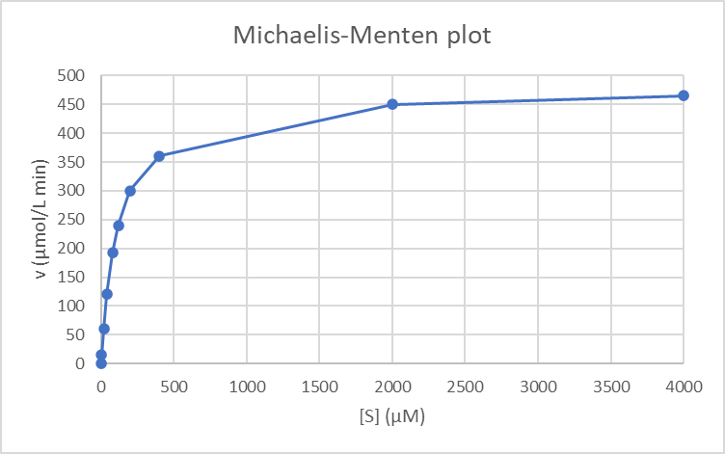
Figure 1. Michaelis-Menten plot (v vs. [S])

If a value of Vmax = 500 μmol/L min is taken, the value of Vmax/2 = 250 μmol/L min lies between the values of [S] = 120 μM (v = 240 μmol/L min) and [S ] = 200 µM (v = 300 µmol/L min). By interpolation, it is possible to calculate Δ[S] = 200 – 120 = 80, which is equivalent to Δv = 300 – 240 = 60. If Vmax/2 = 250 (Δv = 300 – 250 = 50). Interpolation indicates that Δ[S] = 80·50/60 = 66.67. From this data, [S]₅₀ = Km = 200 – 66.67 = 133.33 µM. Depending on the value of Vmax used, different Km values will be obtained (Vmax = 480 μmol/L min, Km = 120 μM; Vmax = 500 μmol/L min, Km = 133.33 μM). Thus, this method is not very confident.

Calculation of the kinetic parameters from Lineweaver-Burk plot using linear regression.

A linear regression can generate more reliable kinetic parameters values than an approximate calculation such as the one made by directly using the Michaelis-Menten equation. The Lineweaver-Burk or double reciprocal plot focuses on reversing the Michaelis-Menten equation. Reversion of the Michaelis-Menten equation gives the Lineweaver-Burk equation:
1/v = (Km/Vmax) (1/[S]) + (1/Vmax)
The representation of (1/v) versus (1/[S]) shows a line, and from the linear regression, the slope of the line will be (Km/Vmax) and the intersection (1/Vmax ). Figure 2 shows the Lineweaver-Burk plot, using all the points of the proposed problem.

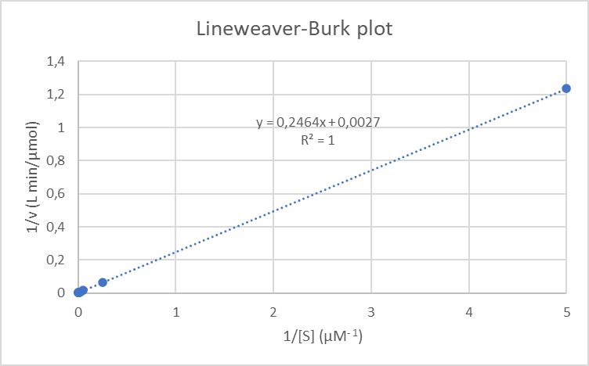
Figure 2. Lineweaver-Burk plot ((1/v) versus (1/[S]). This plot shows all the data for the problem.

The plot of all the data of the problem allows to calculate, from the linear regression, the following values for the kinetic parameters: Vmax = 1/0.0027 = 370.37 μmol/L min and Km = 0.2464/0.0027 = 91.26 µM. It is observed that the Vmax is lower than some of the velocity values obtained at [S] of 2000 μM and 4000 μM. The calculated value of Vmax is therefore not real. The student must also observe that, although R² = 1, the equation of the line is not correct. The points are not correctly distributed along the line, as the plot shows one single point at one end of the line and an accumulation of points at the other end of the line. Since a line always goes through two points, it appears that the line seems correct (with R² = 1), but it is not. It must be considered that when [S] is very low, the error both in the preparation of the substrate concentration and in the determination of the reaction rate, which will also be low, will be much higher than if the [S] is higher. In Figure 2, a lot of weight is given to [S] = 0.2 μM, and if its velocity is wrong, the calculation of the kinetic parameters will also be wrong. Logic indicates that this point, corresponding to a low [S] and a low velocity, should be removed. Figure 3 shows the Lineweaver-Burk plot when the point corresponding to [S] = 0.2 μM and v = 0.81 μmol/L min has been removed.

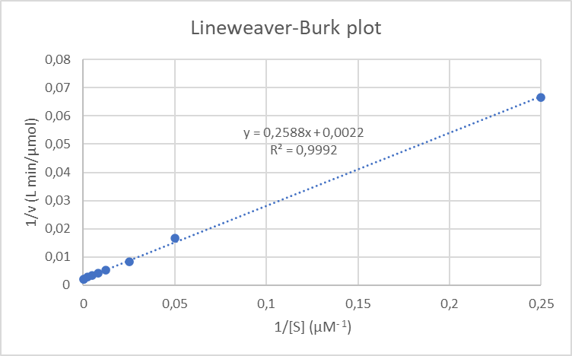
Figure 3. Lineweaver-Burk plot ((1/v) versus (1/[S]). In this graph, the point (5, 1.23) has been removed. This point corresponds to (0.2, 0.81), the lower [S] and lower v.

In Figure 3, the last point is still quite separate from the others. In this case, the following kinetic parameters are obtained: Vmax = 1/0.0022 = 454.54 μmol/L min and Km = 0.2588/0.0022 = 117.64 µM. The value of Vmax = 454.54 μmol/L min is still lower than the rate of [S] = 4000 μM, although the value is close and could be an experimental error. However, we can proceed by removing the second point, corresponding to [S] = 4.0 μM. In this case, Figure 4 is obtained.

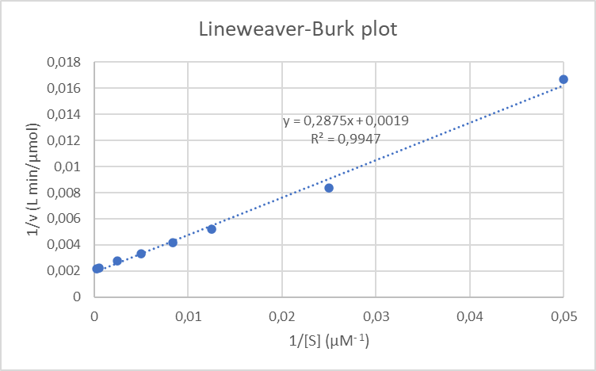
Figure 4. Lineweaver-Burk plot ((1/v) versus (1/[S]). In this graph, the points (5, 1.23), (0.25, 0.067) have been removed. These points correspond to (0.2, 0.81), (4.0, 15), the lowers [S] and lowers v.

The kinetic parameters calculated by removing two points were: Vmax = 1/0.0019 = 526.32 μmol/L min and Km = 0.2875/0.0019 = 151.32 μM. In this case, the parameters are already more real. However, if we eliminate a third point, the results seem better, since now the points are distributed throughout the graph. Figure 5 shows this last plot.

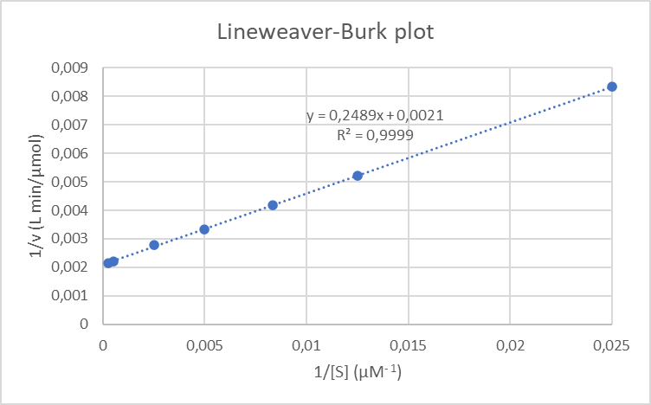
Figure 5. Lineweaver-Burk plot ((1/v) versus (1/[S]). In this graph, the points (5, 1.23), (0.25, 0.067), (0.05, 0.0167) have been removed. These points to (0.2, 0.81), (4.0, 15), (20, 60), the lowers [S] and lowers v.

The kinetic parameters calculated by removing three points were: Vmax = = 1/0.0021 = 476.19 μmol/L min and Km = 0.2489/0.0021 = 118.52 μM.

Calculation of the kinetic parameters from Eadie-Hofstee plot using linear regression.

This type of linear regression is obtained by multiplying the Lineweaver-Burk equation by v·Vmax. Rearranging the equation, we obtain:
v = – Km (v/[S]) + Vmax
The representation of v versus (v/[S]) shows a line, whose slope is directly – Km and its intersection is Vmax. In addition, since the slope is negative, the graph is limited to the space between the two axes, which means that the points are in a limited area. Figure 6 shows this representation.

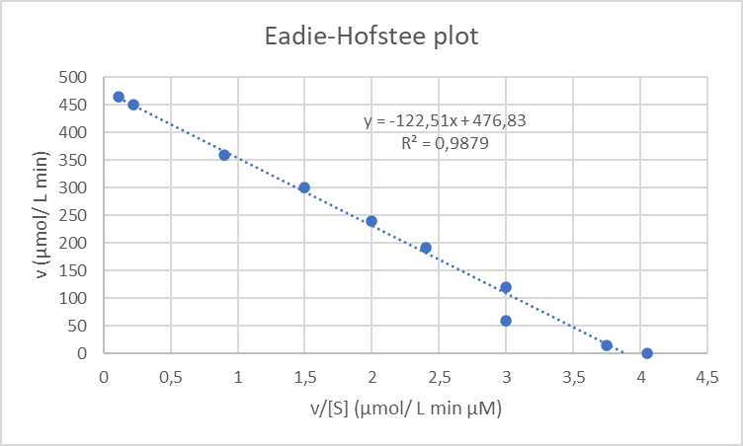
Figure 6. Eadie-Hofstee plot ((v) versus (v/[S]). This plot shows all the data for the problem.

Although in the graph of Figure 6 there is a point that does not fit the line, even if this point is removed, the values of the graph are not affected too much. The following values of the kinetic parameters are obtained: Km = 122.51 μM and Vmax = 476.83 μmol/L min. If the point of v/[S] = 3 μM and v = 60 μmol/L min (which is the one outside the line, with [S] = 20 μM) is removed, the values obtained are: Km = 119.51 μM and Vmax = 476.34 μmol/L min. These kinetic parameters are very similar to those obtained without removing this point. It is not necessary to remove any point to obtain correct values of kinetic constants, and also, the points are distributed along the line.

Calculation of the kinetic parameters from Hanes-Woolf plot using linear regression.

The Hanes-Woolf equation is obtained by multiplying the Lineweaver-Burk equation by [S]:
[S]/v = (1/Vmax) [S] + (Km/Vmax).
The representation of [S]/v versus [S] shows the line in Figure 7, where the slope of the line is (1/Vmax) and the intersection is (Km/Vmax).

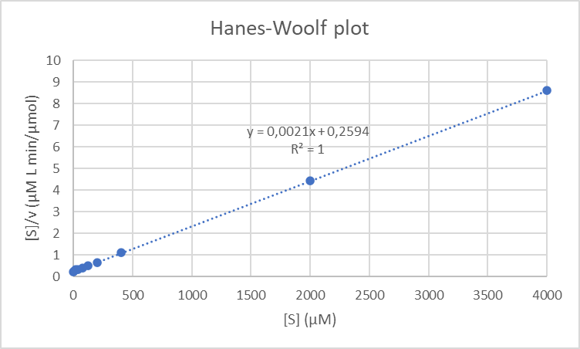
Figure 7. Hanes-Woolf plot (([S]/v) versus ([S]). This plot shows all the data for the problem.

The Hanes-Woolf plot has a positive slope, just like the Lineweaver-Burk plot. But in this case, unlike the Lineweaver-Burk plot, the points on the right of the graph are those with higher [S], which do not have as much error as those on the left of the plot, with lower [S]. Although these points are more separated from the others, as they have a lower error, the parameters obtained are not so much affected if the points are removed. The values of the kinetic constants for the line in Figure 7 are: Vmax = 1/0.0021 = 476.19 μmol/L min and Km = 0.2594/0.0021 = 123.52 µM. When removing the point on the right of Figure 7 (4000, 8.60), corresponding to [S] = 4000 μM and v = 465 μmol/L min, the values of the kinetic parameters obtained are: Vmax = 1/0.0021 = 476.19 μmol/L min and Km = 0.2594/0.0021 = 122.86 µM, very similar to the previous data calculated.

Calculation of the kinetic parameters using a non-linear regression.

A non-linear regression is the most accurate method to obtain the kinetic parameters. On the Internet there are several web pages that allow a non-linear regression for the Michaelis-Menten equation. One of these web pages is designed exclusively for Michaelis-Menten kinetics [Herraez, 2021], and it is not necessary to introduce the equation to fit. Entering the data from Table 1 on this web page, the parameter obtained were: Vmax = 477 ± 3 μmol/L min and Km = 121 ± 3 μM. Table 2 shows a summary of the results obtained by the different methods hereby presented.

Table 2.- Comparison of the kinetic parameters obtained using the various methods.
Method | Vmax (μmol/L min) | Km (μM)
Michaelis-Menten plot | 480  500 | 120  133.33
Lineweaver-Burk plot  ([S] = 0.2 removed)  ([S] = 0.2 and 4.0 removed)  ([S] = 0.2, 4.0 and 20 removed) | 370.37  454.54  526.32  476.19 | 91.26  117.64  151.32  118.52
Eadie-Hofstee plot  ([S] = 3 removed) | 476.83  476.34 | 122.51  119.51
Hanes-Woolf plot  ([S] = 4000 removed) | 476.19  476.19 | 123.52  122.86
Non-linear regression | 477 ±3 | 121±3

Discussion

Non-linear regression is the most accurate method to calculate the kinetic parameters. The results shown in Table 2 indicate that the Vmax varies between 474 and 480 μmol/L min, while the Km varies between 118 and 124 μM. The Michaelis-Menten method is a very inaccurate method since a value of Vmax equal to or greater than 465 μmol/L min must be chosen. If a value from 466 μmol/L min to 473 μmol/L min or a value higher than 481 μmol/L min is taken, the Vmax values would be erroneous. On the other hand, the calculation of the Km will depend on the values of [S] that we have in the zone of v = Vmax/2. Furthermore, when calculating the Km by interpolation we have assumed that, in the zone close to v = Vmax/2, the points follow a linear line, but this is not the case since the plot is hyperbolic. Thus, although Vmax = 500 μmol/L min is taken, the Km obtained by interpolation to a straight line is not, since Km = 133.33 μM is not in the interval of the values obtained by non-linear regression. From the Lineweaver-Burk graph, for this problem, the first 3 points had to be removed to obtain a correct value of Vmax. It is evident that the low [S] can have large errors, which is what happened in this proposed problem. The Eadie-Hofstee and Hanes-Woolf plots are both good in order to obtain the correct kinetic parameters. In the case of the Eadie-Hofstee plot, the values of the kinetic parameters are obtained directly, from the slope and the intersection of the line. However, the Hanes-Woolf plot does not directly generate the kinetic parameters. In this last graph it is also observed, as in the Lineweaver-Burk graph, that the points are not distributed along the line. However, the points that will influence the lineal regression are those with the highest [S] (Figure 7), which have smaller errors. The lowest [S] points, which can be the wrong ones, are all accumulated to the left of the graph, and other more exact points can compensate their errors. After performing the problem in the computer lab classes, the students understand clearly the name of each of the graphs, as well as which plot generates better values when calculating the kinetic parameters. Students can also understand how they should operate to obtain the kinetic parameters by means of a non-linear regression method.

Conclusion

Michaelis-Menten graph does not allow an exact calculation of the parameters, since it depends on the value that we decide to give to Vmax. This value is improvised, and Km values are calculated depending on it, and thus they can be very different depending on which Vmax is taken.

With all the data in the problem, the Lineweaver-Burk method is the most inaccurate, as errors in the low [S] can lead to miscalculations of the parameters.

The linear methods that generate the best results are those obtained with the Eadie-Hofstee and Hanes-Woolf graphs. However, the Eadie-Hofstee plot directly determines the parameters from the slope and the intersection of the line. For this reason, the Eadie-Hofstee graph is the most used in scientific articles on enzyme kinetics.

Acknowledgements

The authors belong to the consolidated teaching innovation group QuiMet (Metabolism in the Chemistry Degree) (GINDOC-UB/180) and we thank RIMDA, Universitat de Barcelona, for recognizing our work. We also thank RIMDA, Universitat de Barcelona, for financing our project “Biochemistry Escape-room for self-learning: carbohydrates, amino acids, lipids, enzymes, transporters, and receptors” (2022PMD-UB/020).

References

Augustinsson, K. B. (1948). A study in comparative enzymology. Acta Physiol. Scand. 15, Suppl. 52.
Eadie, G.S. (1942). The inhibition of cholinesterase by physostigmine and prostigmine. Journal of Biological Chemistry, 149, 775-777.
Hanes, CS (1932). Studies on plant amylases: The effect of starch concentration upon the velocity of hydrolysis by the amylase of germinated barley. Biochemical Journal 26 (5): 1406-1421.
Herráez, A (2021). Regresión no lineal por mínimos cuadrados aplicada a la cinética de Michaelis y Menten, http://biomodel.uah.es/metab/enzimas/MM-regresion.htm
Hofstee, B. H. J. (1952). On the evaluation of the constants Vm and KM in enzyme reactions. Science 116 (1952) 329-331.
Lineweaver, H., Burk, D. (1934). The determination of enzyme dissociation constants. J. Am. Chem. Soc. 56(3), 658-666.
López-Nicolás, J.M., García-Carmona, F. (2015). Los cuatro mosqueteros de la cinética enzimática. Revista Eubacteria. Cien años de avance en ciencias de la vida. 34, 39-43. ISSN 1697-0071.
Michaelis, L., Menten, M.L. (1913). Die Kinetik der Invertinwirkung. Biochem. Z. 49, 333-369.
Segel, I. H. (1975). Enzyme Kinetics. Wiley, New York.

