Contamination effects in photosynthetic pigments and their Statistical data processing of Populus plants in Metalurgicall area.

Eriola Hida
Polytechnic University of Tirana, Albania, eri_zhuri@yahoo.com -

Zhifka Muka
Polytechnic University of Tirana, Albania, zhifkamuka24@yahoo.com

Abstract: Leaves, because different mechanisms and structures that contribute to absorption reflection and transmission, appear as an environment with high heterogeneity, the optical properties of which depend on multiple dispersal of inside radiation (Bushmann et al., 1998).
Diffusion of radiation inside the leaf determines the average optical path of the radiation, which exceeds several times the thickness of the leaf and thus, causes an additional effect on the radiation absorbed (Gitelson et al, 1996).This increases the probability that a large part of the radiation captured by pigments.
In plants, chlorophyll is a pigment directly involved in the conversion of light energy into chemical energy. The main photoreceptor in chloroplasts of higher plant, is chlorophyll a. In addition to chlorophyll a, they contain chlorophyll b and carotenoids.
Structurally, all types of chlorophyll are similar to each other. They all contain four pyrrole rings (also called porphyrin), which are bonded together with double bonds of methane (CH =) which determine the spectroscopic properties of these pigments. The skeleton of each pyrrole ring is composed of five atoms (four carbon and one nitrogen), with the magnesium atom in the center as the nucleus (fig. 1.9), (Lichtenthaler et al., 1987; Lichtenthaler et al., 2004).
Measuring the parameters of Chl fluorescence are increasingly used in the last three decades of research in photosynthesis and plant ecology.
Greater efforts in scientific research, in recent times, are made discoveries because relations - a result that exist between phenomena. The process of discovery of these deterministic models in terms of the science of statistics, explained by the association. While quantitative expression of the form and extent of connections between phenomena appear through regression and correlation.
Contamination effect reflected on photosynthetic activity of leaves was very high particularly on plants located nearer the metallurgical units.
The elements monitored in the metallurgical area are: air suspended solids (LNP), solids with particle dimensions less than 10 microns (PM10), lead content (Pb) in the air, sulfur dioxide content ( SO2) in air, nitrogen dioxide content (NO2) in air, ozone content (O3) in air. In this territory the operators exercise their activity: Steel plant, "Kurum", cement factory "ECF", Ferro-Chrome plant "ACR" sh.p.k., former DARFO.

Keywords: Chlorophyll fluorescence imaging, Steel plant, Induction kinetics, Photosynthetic apparatus, Statistical processing.

Introduction

Measurement of Chl fluorescence parameters is being used more and more in the last three decades in research in photosynthesis and in plant ecology. These measurements allow the Chl fluorescence signals to be determined from small, detached leaf surfaces. In each such measurement, only information on the fluorescence characteristics of Chl in these particular parts of the leaf can be obtained. The information obtained is not representative of the entire leaf surface. Measurement of fluorescence signals in a larger number of "small" leaf areas provides more complete information on the general condition of the photosynthetic apparatus in the leaves. However, even in this case the number of measurements is limited and does not provide information on the distribution of photosynthetic activity and the fluorescence characteristics of chlorophyll throughout the leaf surface.
To overcome these difficulties, as well as the lack of information on the possible gradients of photosynthetic conversion of light quanta, in collaboration with physicists, the induced fluorescence imaging system was constructed, where as a source of fluorescence excitation is used laser, xenon lamp or photodiode. This system provides information in more than 100,000 pixels per leaf area, on the fluorescence of Chl and the photosynthetic characteristics of all the different parts of the leaf.
High temperatures combined with stresses and industrial pollution generated by the metallurgical plant affect the reduction of the activity of the photosynthetic apparatus of the leaves.
Industrial pollution as well as other stresses reduces the activity of the photosynthetic apparatus of the leaves. The elements monitored in the metallurgical area are: air suspended solids (LNP), solids with particle dimensions less than 10 microns (PM10), lead content (Pb) in the air, sulfur dioxide content ( SO2) in air, nitrogen dioxide content (NO2) in air, ozone content (O3) in air. In this territory the operators exercise their activity: Steel plant, "Kurum", cement factory "ECF", Ferro-Chrome plant "ACR" sh.p.k., former DARFO.
The detection of air pollution from metallurgical plants has been analyzed in the endemic plant Populus x canadensis (Poplar) at different distances from the source of pollution.
Statistical analysis was performed using the statistical program JMP 7.0

Material And Methods Plant Material
Plant materials

The materials that we choose are Populus x canadensis Moench (Populus deltoides Marsh. x Populus nigra L) grown in different steel plant pollution conditions were analyzed.
All areas are selected in the Metallurgical Plant, but near different sources of pollution.

Study areas were chosen

- Area E (3.5 km) away from the ferrochrome factories in the Metallurgical area, Elbasan, Albania
- Area D (3 km) away from the ferrochrome factories in the Metallurgical area, Elbasan, Albania
- Area C (2.7) km away from the ferrochrome factories in the Metallurgical area, Elbasan, Albania;
- Area B (2.5) km away from the ferrochrome factories in the Metallurgical area, Elbasan, Albania
- Area A Vidhas (200 m) away from the ferrochrome factories in the Metallurgical area, Elbasan, Albania
The Vidhas area is an area located near the ferrochrome plant which emits a high amount of pollution. This area is also under the effect of urban transport pollution. The areas 2.5 km and 2.7 km from the ferrochrome plant are located near the source of pollution from the metal crushing and steel processing plant (at a distance of 300 m and 100 m) therefore they are areas with a very high level of pollution. Areas located at a distance of 3 km and 3.5 km from the ferrochrome plant are areas located near the metal chipping and the plant and lime (at a distance of 70 m and 200 m). Regarding the other two areas that are located at a distance of 4 km and 4.5 km from the ferrochrome plant are areas that are under the effect of urban pollution but also in the effect of pollution of lime processing (at a distance of 500 m and 1 km) all presented in (Fig 1). The measurements were carried out at three different times: spring, summer, and autumn and 2012. The spring period is with optimal conditions, sufficient lighting, without stress and with sufficient humidity. The summer period is with high dryness, lighting and high temperature. Also the autumn period is stressful
The areas where the leaf samples were taken were defined at different distances and directions from the source of contamination, the ferrochrome plant. Seven areas were taken at different distances from the source of pollution, the ferrochrome plant. In the 200 m area the main sources of pollution are the ferrochrome plant and urban transport. Areas located at a distance of 2.5 km and 2.7 km from the ferrochrome plant are located near the source of pollution from the lamination and steel plant therefore are areas with a very high level of pollution. The area located at a distance of 3 km from the ferrochrome plant is an area located near the metal chipping plant, while the area located at a distance of 3.5 km is an area located near the lamination plant. As for the other two areas located at a distance of 4 km and 4.5 km from the ferrochrome plant are areas located in the effect of urban pollution. Meanwhile, leaf samples in the Dajti area were taken as control leaves.
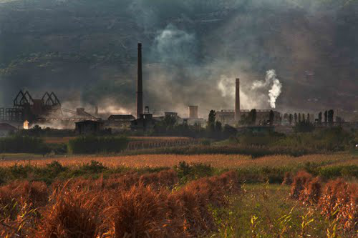
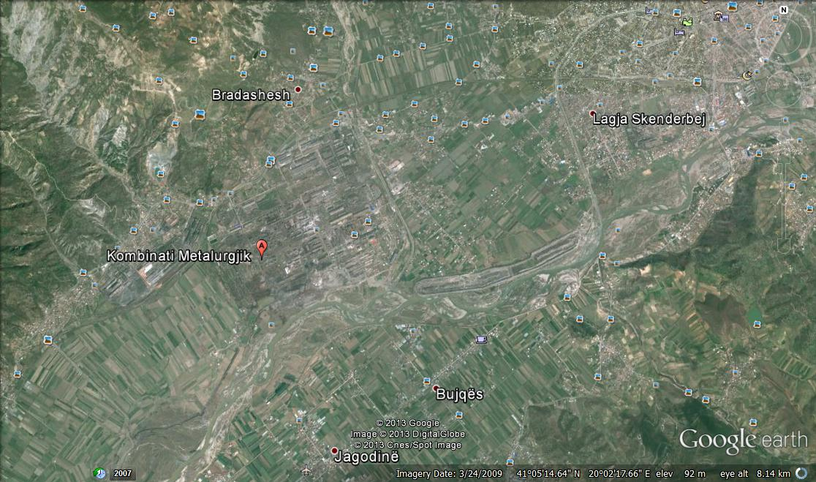
Metalurgicall
Vidhas
2.5 km
2.7 km
3 km
4 km
4.5 km
3.5 km
O1
O2
O3
O4
O5

Figure 1. Geographical map of selected areas in the Metallurgical Plant, Elbasan

Geographical coordinates measured with GPS, of all experimental areas in the Metallurgical Plant, Elbasan, where leaf samples are selected are presented in (Table 1)

Table 1. Geographical coordinates of experimental areas in the Metallurgical Plant, Elbasan
Selected areas | Latitude (Y) | Latitude (X)
Area A (200 m) | 41° 5'18.94" | 20° 0'20.54"
Area B (2.5 km) | 41° 5'43.18" | 20° 1'39.18"
Area C (2.7 km_ | 41° 5'47.80" | 20° 1'41.28"
Area D (3 km) | 41° 5'51.81" | 20° 1'46.46"
Area E (3.5 km) | 41° 5'36.27" | 20° 2'15.34".
Area F (4 km) | 41° 6'11.56" | 20° 1'37.60"
Area G (4.5 km) | 41° 6'15.64" | 20°1'34.53"

Methods
Extraction of pigments from leaves

Pigment extraction is performed according to established methods (Buschmann & Lichtenthaler, 1988): After cutting the middle part of the leaves in the form of discs, for each extraction discs are taken only from one leaf with a diameter of 0.9 cm
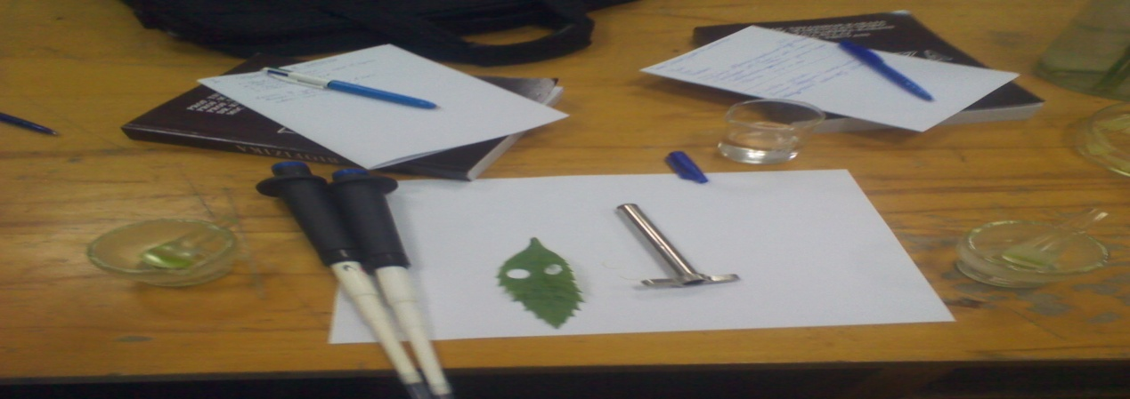
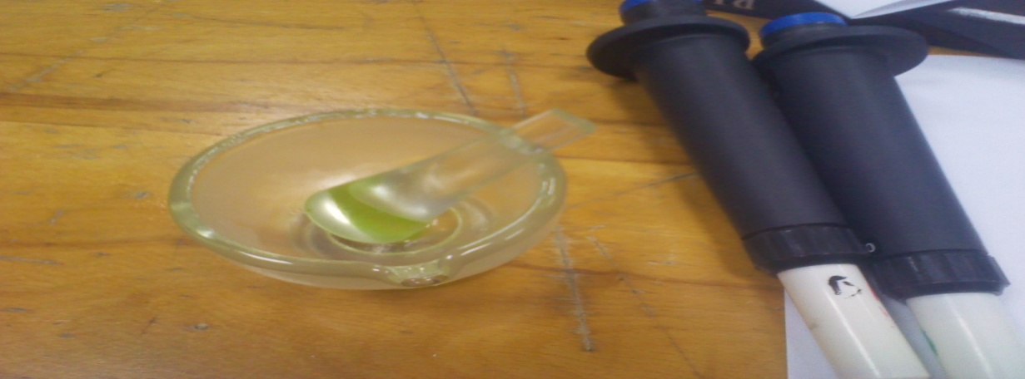

Figure 1. View from the extraction

The extraction was done by pressing in havana porcelain the discs cut from the leaves with 1-2 ml of 80% acetone (in volume) and with additional quartz sand. Acetone was used as the solvent as it is considered to be more suitable in the case of tissues with high water content. MgCO3 (1g in 200 ml) was added during extraction to prevent chlorophyll feofetization.

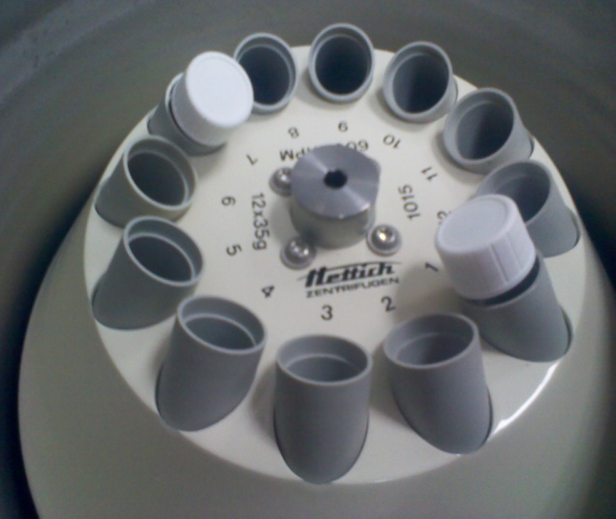
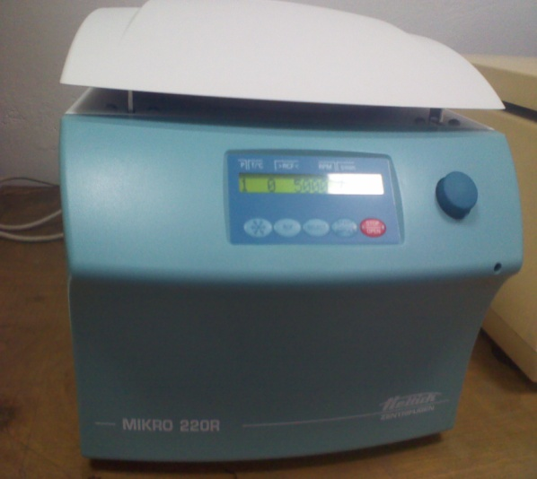
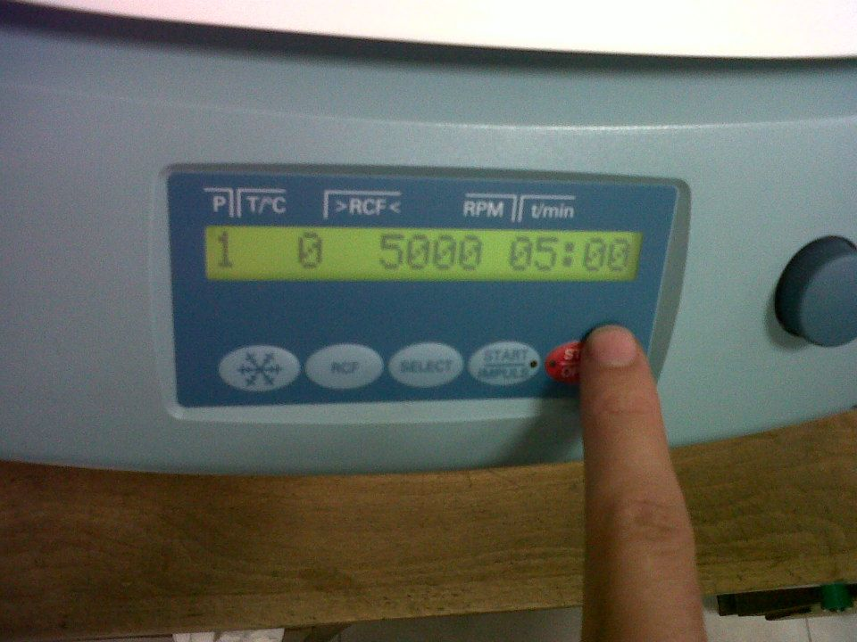

Figure 2. View from the centrifuge

The extract is passed into centrifuge tubes. After adjusting the volume to 5 ml, centrifuge for 5 min at 6000 rpm. The determination of pigments was done based on the non-destructive spectrophotometric method. The method relies on the fact that the absorption spectra of chlorophyll a, chlorophyll b and carotenoids allow to determine their content in the extract without their prior separation

The FluorCam system allows two-dimensional recording of the induced fluorescence of chlorophyll according to the relevant lighting protocols. The dimensions of the studied object are not bigger than 10  13 cm (Lichtenthaler & Babani, 2004; Govindjee et al., 2004.).

Figure 3. FluorCam system and sample radiation chamber. Control panel with LCD display (3), control buttons (4), sample room with CCD camera (5) and the part where the sample is placed (6).

Statistical Aanalysic
All experimental data were processed by Student’s, Turkey-Kramer methods and Analysis of Variance (P <0.05). Data are presented as averages accompanied by standard error and standard deviation.
The averages were compared by Student’s Test accompanied by a letter indicating the variation between them. Outcome tables are accompanied by one-way ANOVA tables and graphs showing the variation between different treatments (P <0.05).
Statistical analysis was performed using the statistical program JMP 7.0
Regression analysis, in its research actions, includes three areas of research on the interrelationships between phenomena: covariance, regression and correlation.

Results

Photosynthetic pigments in the Metallurgical area
It is noticed that the content of photosynthetic pigments in the leaves of selected plants in the Metallurgical area, as an area where the plants are exposed to high industrial pollution, drought conditions and high light is lower compared to other areas presenting lower values in plants located at distances very close to the source of pollution. In the leaves of green plants the content of photosynthetic pigments is higher than in the leaves of non-green plants. Also in the period June the values of Kla, Klb are higher than the other two periods August and October.

June period
Table 1. Content of photosynthetic pigments of the leaves Polulus x canadensis (Poplar), June period for all areas
Period | Kla  (mg/dm ) | Klb  (mg/dm ) | x+c  (mg/dm ) | Kl(a+b)  (mg/dm )
Area E | 7.335 | 2.268 | 2.134 | 9.603
Area D | 6.191 | 2.159 | 1.940 | 8.350
Area C | 5.163 | 1.803 | 1.800 | 6.967
Area B | 4.795 | 1.334 | 1.423 | 6.129
Zona A | 4.170 | 1.616 | 1.788 | 5.786
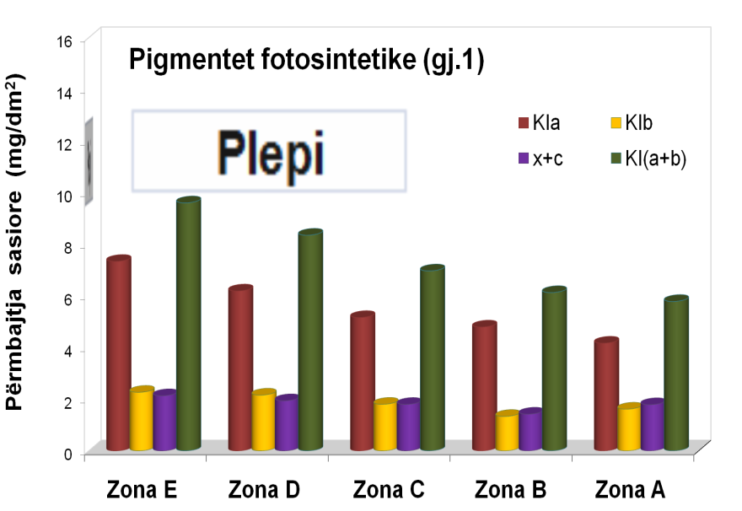
Photosynthetic Pigments
Quantitative content
AreaE
Area C
Area B
AreaD
Area A

August Period

Table 2. Content of photosynthetic pigments of the first leaves Polulus x canadensis (Poplar), August period for all areas
Period | Kla  (mg/dm${}^{2}$) | Klb  (mg/dm${}^{2}$) | x+c  (mg/dm${}^{2}$) | Kl(a+b)  (mg/dm${}^{2}$)
Area E | 6.5 | 1.902 | 1.846 | 8.402
Area D | 5.816 | 1.966 | 2.009 | 7.783
Area C | 5.004 | 1.533 | 1.577 | 6.536
Area B | 4.588 | 1.382 | 1.391 | 5.97
Area A | 3.713 | 1.093 | 1.265 | 4.806

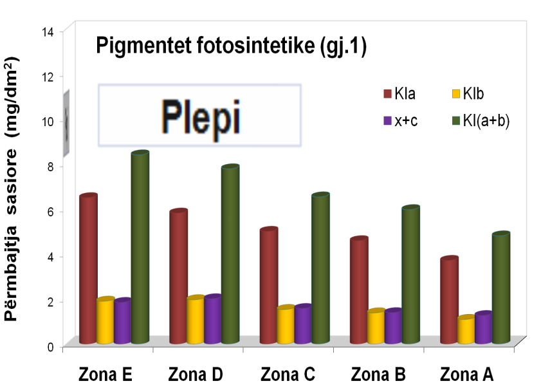
Figure 2. Photosynthetic pigments of the first leaves Polulus x canadensis (Poplar), August period for all areas
Photosynthetic Pigments
POPULUS
Quantitative content

Area E
Area A
Area B
Area C
Area D

Induced fluorescence parameters in the studied areas

Looking at the above parameters we notice that in the all area in all two periods, the fluorescence parameters decrease from the period June to the other August periods August and October. Also in the same period comparing the two types of samples higher values of RFd are observed in the poplar leaf in the E area compare to others areas.

June Period

Table 3. Mean values of induced fluorescence parameters of the of Populus x canadensis Moench (Poplar) in all areas, June
Fluorescence Parameters | Fo | Fm | Fv | Fo' | Fm' | Fv'
Area A | 143.1 | 459.2 | 316.1 | 103.8 | 179.4 | 42.4
Area B | 82.5 | 348.8 | 266.4 | 94.7 | 133.7 | 39.0
Area C | 127.1 | 551.6 | 424.5 | 124.2 | 176.2 | 52.0
Area D | 123.5 | 424.7 | 301.3 | 101.3 | 137.4 | 36.0
Area E | 149.2 | 576.1 | 426.9 | 132.2 | 181.9 | 49.8

August Period

Table 4. Mean values of induced fluorescence parameters of the of Populus x canadensis Moench (Poplar) in all areas, August
Fluorescence Parameters | Fo | Fm | Fv | Fo' | Fm' | Fv'
Area A | 108.5 | 321.5 | 213.0 | 134.4 | 170.6 | 36.1
Area B | 114,7 | 433,1 | 318,4 | 131,5 | 178,3 | 46,7
Area C | 95.0 | 399.6 | 304.6 | 110.8 | 156.6 | 45.8
Area D | 126.6 | 502.6 | 376.0 | 127.6 | 178.9 | 51.3
Area E | 121.3 | 523.4 | 402.2 | 121.5 | 184.2 | 62.7
Table 4. RFd fluorescence ratio of the first leaves of Populus x canadensis Moench (Poplar) in all areas and periods
RFd |  | Area E |  | Area D | Area C |  | Area B | Area A
June | 2.59 |  | 2.55 |  | 2.46 | 2.23 |  |  | 1.78
August | 2.3 |  | 2.14 |  | 1.12 |  | 1.97 |  | 1.43

Figure 3. RFd fluorescence ratio of the first leaves of Populus x canadensis Moench (Poplar) in all areas and periods
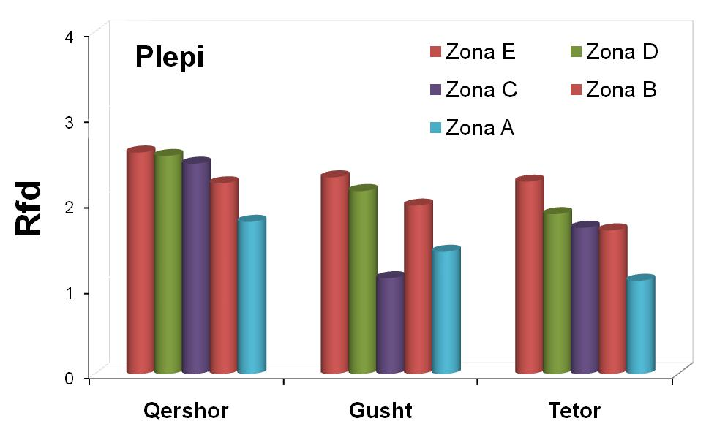

Presentation of logarithmic function and correlation coefficient

The following graph shows the relationship between the ratio of Rfd fluorescence drop with the content of photosynthetic pigments for the sample Populus x canadensis Moench (Poplar) for the first leaves in the three measurement periods. This graph clearly shows the low value of Rfd and chlorophyll content in August and highest in June.

Graphical representation shows that between periods and their zones there is a nonlinear relation expressed with a logarithmic function y = 1.662 ln (x) - 1.053 and correlation coefficient R2 = 0.846.

It is noticed that in all three areas there is a decrease in the ratio of fluorescence and chlorophyll content in the first leaves compared to the second leaves. Comparing the areas with each other it is clear that in all three periods area A has lower values of Rfd and Kl (a + b) compared to the other two areas (Area G, Area F).

Figure 4. Dependence between fluorescence drop ratio and chlorophyll content presented for the first leaves of Populus x canadensis Moench (Poplar)
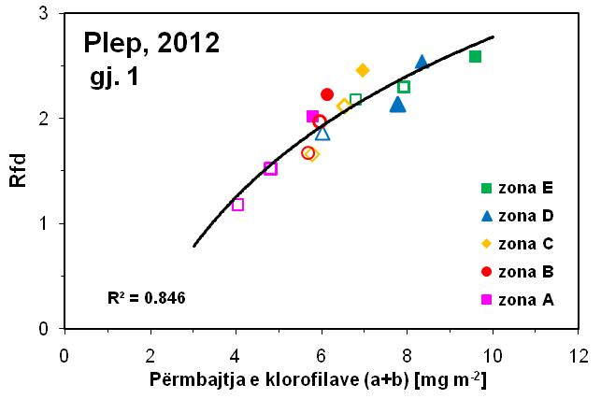
Populus
Area E
Area D
Area A
Area C
Area B
Chlorophyll

Statistical processing through the Anova program
Statistics is data science. It involves the collection, classification, organization, analysis and interpretation of numerical information in order to make efficient decisions.
In all periods being compared to each other there is variation of the fluorescence ratio and there is the content of photosynthetic pigments for the first and second leaves for the four areas. Comparing the areas in the period there is a change in the fluorescence ratio and there is a content of photosynthetic pigments for the first and second leaves for the four areas. Also in the period there is change in the fluorescence ratio and there is the content of photosynthetic pigments for the first and second leaves for the four areas. Comparing the areas in October there is a change in the fluorescence ratio and there is a content of photosynthetic pigments for the first leaves for the four areas.
Table 5. Analysis of variance for the parameters in the study for the sample Populus x canadensis (Poplar), comparing the areas in all periods (June, August, October)
Source | DF | SS | MS | ValueF | F Critic | Prob
Areas | 4 | 5.284 | 1.321 | 10.309 | 2.539 | 2.66E-06
C.Inside Group | 55 | 7.048 | 0.128
C. Total | 59 | 12.333

Content of photosynthetic pigments, Cl (a + b)
Source | DF | SS | MS | ValueF | F Critic | Prob
Areas | 4 | 75.969 | 18.992 | 18.978 | 2.539 | 7.45E-10
C.Inside.group | 55 | 55.04 | 1.000
C. Total | 59 | 131.01

Statistical processing of data with JMP-7.0 program

Statistical data processing performed through the program (ANOVA) presents the analysis of variance in different periods of sample study during the years 2011-2012. Differences are noticed between the period of June, August with the period of October in all areas.
Even in the analysis of variance for the fluorescence ratio for the first and second leaf, the Poplar sample and in the Student and Kramer criterion, statistically significant differences are observed between the zones for each period. These differences are high especially in the period August and October where the plants are under the effect not only of metallurgical pollution but also other stresses of the respective season.

Figure 5. One-way analysis of Rfd 1 for the sample Populus x canadensis (Poplar)
in all areas and periods
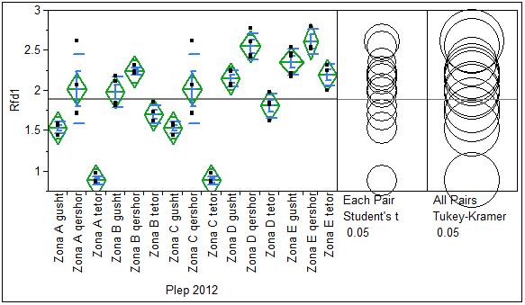
Populus
Area A August
Area A June
Area A B June
Area B August
Area C August
Area C June
Area D August
Area D June
Area E August
Area E June

Table 6. Statistical processing of data using two Rfd 1 criteria for the sample Populus x canadensis (Poplar) in all areas and periods
Areas and Periods | Std | StdErro | StdDev | Test Student | Test Tukey-Kramer HSD
Area A August | 1.5275 | 0.0971 | 0.0722 | 2.6100 | 2.6100
Area A June | 2.0150 | 0.0971 | 0.4296 | 2.5450 | 2.5450
Area B Augist | 1.9750 | 0.0971 | 0.1873 | 2.2325 | 2.2325
Area B June | 2.2325 | 0.0971 | 0.0457 | 2.1875 | 2.1875
Area C August | 1.5275 | 0.0971 | 0.0722 | 2.0150 | 2.0150
Area C June | 2.0150 | 0.0971 | 0.4296 | 2.0150 | 2.0150
Area D August | 2.1425 | 0.0971 | 0.1021 | 1.8025 | 1.8025
Area D June | 2.5450 | 0.0971 | 0.1658 | 1.6925 | 1.6925
Area E August | 2.3500 | 0.0868 | 0.1617 | 1.5275 | 1.5275
Area E June | 2.6100 | 0.1121 | 0.1562 | 0.8800 | 0.8800

Based on the analysis of variance for chlorophyll content for the first and second leaf and the Student and Kramer criteria, not very high statistical differences are observed between the zones for each period.

Figure 6. One-way analysis of Cl (a + b) -1 for the sample Populus x canadensis (Poplar) in all areas and periods
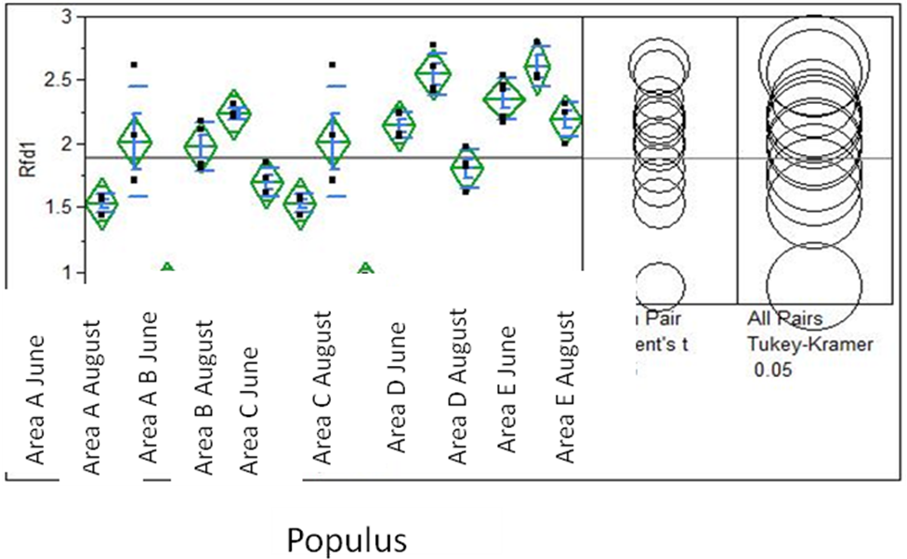

Table 7. Statistical processing of data using two criteria of Cl (a + b) -1 for the sample Populus x canadensis (Poplar) in all areas and periods
Areas and Periods | Std | StdErro | StdDev | Test Student | Test Tukey-Kramer HSD
Area A August | 4.8057 | 0.3268 | 0.5340 | 9.6143 | 9.6143
Area A June | 5.7862 | 0.3268 | 0.8902 | 8.3502 | 8.3502
Area B August | 5.9700 | 0.3268 | 0.6896 | 7.7827 | 7.7827
Area B June | 6.1287 | 0.3268 | 0.3550 | 6.7802 | 6.7802
Area C August | 4.8057 | 0.3268 | 0.5340 | 6.0200 | 6.0200
Area C June | 5.7862 | 0.3268 | 0.8902 | 5.9700 | 5.9700
Area D August | 7.7827 | 0.3268 | 0.2599 | 5.7862 | 5.7862
Area D June | 8.3502 | 0.3268 | 0.5793 | 5.6755 | 5.6755
Area E August | 8.2564 | 0.2923 | 1.1795 | 4.8057 | 4.8057
Area E June | 9.6143 | 0.3773 | 0.2765 | 4.0242 | 4.0242

Conclusion

- The content of photosynthetic pigments in the leaves of the plant Populus x canadensis (Poplar), selected in the Metallurgical are is lower in are A compared to zones B, C, D and E located at a greater distance large from the source of pollution, the ferrochrome plant. Under stress conditions such as drought conditions, high light period October, it is observed that the content of photosynthetic pigments decreases compared to the period June. The values of photosynthetic pigments in the three periods for Bradashe are: in June the values are: Cl (a + b) = 5.786 for leaves and for the period August Cl (a + b) = 4.806 for leaves.
- The content of photosynthetic pigments in the leaves of the plant Populus x canadensis (Poplar), selected in the Metallurgical area is higher in area B compared to area A located at a distance of 2.5 km from the ferrochrome plant but in a distance of 100 m from the impact of pollution emitted by the metal lamination and steel processing area. In stress conditions such as drought conditions, high light period August, it is observed that the content of photosynthetic pigments decreases compared to the period June.
- The content of photosynthetic pigments in the leaves of the plant Populus x canadensis (Poplar), selected in the Metallurgical area is higher in area C compared to area A and B located at a distance of 2.7 km from the ferrochrome plant but at a distance of 300 m from the impact of pollution emitted by the metal lamination and steel processing plant.
- The content of photosynthetic pigments in the leaves of the plant Populus x canadensis (Poplar), selected in the Metallurgical area is higher in area D compared to area A, B and C located at a distance of 3 km from the plant of ferrochrome but at a distance of 70 m from the impact of pollution emitted by the steel plant.
- The content of photosynthetic pigments in the leaves of the plant Populus x canadensis (Poplar), selected in the Metallurgical arae is higher in arae E compared to area A, B, C and C located at a distance of 3.5 km from the ferrochrome plant but at a distance of 200 m from the impact of pollution emitted by the lamination and lime processing plant.
- . It is noticed that comparing area A with area B which is further away from the source of pollution, the ferrochrome plant at a distance of 2.5 km, the RFd fluorescence ratio images of Populus x canadensis (Poplar) have higher values in arae B. In the June period the values are: (Rfd = 2.23 and Fm / Fo = 4.23) for the leaves, for the period August (Rfd = 1.97 and Fm / Fo = 3.77) for leaves
- Comparing area A and area B with zone C farthest from the source of pollution, the ferrochrome plant at a distance of 2.7 km, the RFd fluorescence ratio images of Populus x canadensis (Poplar) have higher values in area A and B. In the June period the values are: (Rfd = 2.46 and Fm / Fo = 4.36) for leaves, for the period August (Rfd = 2.12 and Fm / Fo = 4.20) for leaves
- Comparing area A, area B, area C with area D farthest from the source of pollution, the ferrochrome plant at a distance of 3 km, the RFd fluorescence ratio images of Populus x canadensis (Poplar) have higher values in area D compared to other areas. In the June period the values are: (Rfd = 2.55 and Fm / Fo = 3.67) for the leaves, for the period August (Rfd = 2.14 and Fm / Fo = 3.87) for leaves
- Comparing area A, area B, area C, area D with area E farthest from the source of pollution, the ferrochrome plant at a distance of 3.5 km, the RFd fluorescence ratio images of Populus x canadensis (Poplar) have the highest values high in area E compared to other areas. In the June period the values are: (Rfd = 2.59 and Fm / Fo = 3.86) for the leaves, for the period August (Rfd = 2.30 and Fm / Fo = 4.30) for leaves.

Recommendations
In the future we recommend that this measures to continue in different vegetables grow near these areas.

References
References and citations should be prepared in the latest APA (https://owl.purdue.edu/owl/research_and_citation/apa_style/apa_style_introduction.html) format. References have to be cited in the paper. See the reference examples below.

Karukstis, K.K., 1991. Chlorophyll fluorescence as a physiological probe of the photosynthetic apparatus. In Scheer, H. (ed.) Chlorophylls: f. 769–795. CRC Press, Boca Raton.
Havaux M., Strasse R. J., Greppin H., 1991: A theoretical and experimental analysis of the q_{P} and q_{N} coefficients of chlorophyll fluorescence quenching and their relation to photochemical and nonphotochemical events.
Journal Photosynthesis Research, Volume 27, Issue 1: f. 41-55.
Strasser, R.J. and Govindjee L.O., 1992a. The Fo and the O-J-I-P fluorescence rise in higher plants and algae. I
n Argyroudi-Akoyunoglou, J.H. (ed.) Regulation of Chloroplast Biogenesis: f. 423–426. Plenum Press, New York.
Rosenqvist E., 1993: Chlorophyll Fluorescence: A General Description and Nomenclature.
Olaf van Kooten, springer. Journal of Photochemistry and Photobiology B: Biology. Volume 19, Issue July 1993: f. 97–104.
Dau, H., 1994b. Short-term adaptation of plants to changing light intensities and its relation to photosystem II photochemistry and fluorescence emision. The fluorescence transient as a tool to characterize and screen photosynthetic samples 481.
J. Photochem. Photobiol. 26: f. 3–27.
Rohacek K., Dau H., 1994: Chlorophyll Fluorescence Parameters: The Definitions, Photosynthetic Meaning, and Mutual Relationships. Molecular mechanisms kuantitative models of variabile photosystem II fluorescence.
Volume 60, Issue 1: f. 1–23, July 1994. Photosynthesis Research May 1993, Volume 36, Issue 2: f. 119-139.
Babani F., 1994. “Disa karakteristika spektrale te kloroplasteve te grurit ndaj stresit te temperatures se larte.”
Punimete I.K.B., Nr. 9, 1994: f. 48-54.
Tsimilli-Michael, M., Krüger, G.H.J. and Strasser, R.J., 1995. Suboptimality as driving force for adaptation: A study about the correlation of excitation light intensity and the dynamic fluorescence emission in plants.
In Mathis, P. (ed.) Photosynthesis: From Light to Biosphere, Vol 5: f. 981–984. Kluwer Academic, The Netherlands.
Babani F., 1995.“Ndryshimi i aktivitetit fotosintetik gjate ndriçimit tefilizave te etioluar te elbit”.
Punimete I.K.B., Nr. 10: f. 63-67.
Sauer, K. and Debreczeny, M., 1996. Fluorescence.
In Amesz, J. and Hoff, A.J. (eds) Biophysical Techniques in Photosynthesis: f. 41–61. Kluwer Academic, The Netherlands.
Srivastava, A. and Strasser, A., 1996. Stress and stress management of land plants during a regular day.
J. Plant Physiol. 148: f. 445–455.
Hartmut K., Lichtenthaler HK., 1997: Fluorescence imaging as a diagnostic tool for plant stress.
Trends in Plant Science Volume 2, Issue 8: f: 316-320.
Srivastava, A. and Strasser, R.J., 1997. Constructive and destructive actions of light on the photosynthetic apparatus.
J. Sci. Indust. Res. 56: f. 133–148.
Strasser, R.J., Tsimilli-Michael, M. and Greppin, H., 1997. How excitation energy distribucion indicates the complexity of a developing and to the environment adapting photosynthetic apparatus.
In Greppin, H., Penel, C. and P. Simon, P. (eds) Travelling Shot on Plant Development: f. 99–129. Rochat-Baumann, Imprimerie Nationale, Genčve.
Stirbet, A., Govindjee, Strasser, B.J. and Strasser R.J., 1998. Chlorophyll a fluorescence induction in higher plants: modelling and numerical simulation.
J. Theor. Biol. 193: f. 131–151.
Babani F. and Bozo S., 1998: “Effect of high irradiance on chlorophyll induction fluorescence of wheat leaves.” Journal of Natural and Technical Sciences, Acad. Sciences, Tirana, 4: f. 13-21.
Strasser, R.J., Srivastava, A. and Tsimilli-Michael, M., 1999. Screening the vitality and photosynthetic activity of plants by fluorescent transient.
In Behl, R.K., Punia, M.S. and Lather, B.P.S (eds) Crop Improvement for Food Security: f. 72–115. SSARM, Hisar, India.
Maxwell K., Johnson G. H., 2000: Chlorophyll fluorescence—a practical guide.
Photosynthetica 2002, Volume 40, Issue 1: f. 13-29.
Lichtenthaler H. K., Babani F.,2004.Light adaptation and senescence of the photosynthetic apparatus. Changes in pigment composition, chlorophyll fluorescence parameters and photosynthetic activity during light adaptation.
AHP Fluorescence book Vol. 19.George C. Papageorgiou and Govindjee (eds): Chlorophyll Fluorescence: A Signature of Photosynthesis, © 2004 Kluwer Academic Publishers. Printed in The Netherlands, Kap. 28.
Lichtenthaler H. K.,Fatbardha B., Navrátil M.,Buschmann C., 2013, Chlorophyll fluorescence kinetics, photosynthetic activity, and pigment composition of blue-shade and half-shade leaves as compared to sun and shade leaves of different trees.
Photosynthesis Research, Volume 117, Issue 1-3: f. 355-366.

