**Effect of Heat Treatments on the Corrosion Resistance of Carbon Steel Using Salt Water**

**Ghaidaa Ibrahem Alsarraj**

College of Engineering, University of Mosul , Iraq, [Ghaidaa.alsarraj2019@uomosul.edu.iq](mailto:Ghaidaa.alsarraj2019@uomosul.edu.iq)

**Ekhlas Ahmed Basheer**

College of Electronics Engineering , Ninevah University, Iraq, ekhlas.basheer@uoninevah.edu.iq

**Abstract**:The aim of this research is to study the corrosion behavior of carbon steel ,because corrosion is common defects that occur to the devices and machinery after manufactured . Plain –carbon steel is considered as one of the most important minerals used in industrial applications. The direct effect on the corrosion behavior of steel is heat treatments because of galvanic corrosion which building up between its microscopic phases. In three methods carbon steel has been treated thermally which the hardening, normalizing, and annealing . Used salt water as corrosive media for a period of (30,45,60) days. , the steel contains chemical compounds to show its effect on the corrosion. To compare between the results and to determine corrosion rate used weight loss . The results obtained show that the lowest corrosion resistance is for the hardened steel and the corrosion resistance of the annealing steel is the greatest, while the corrosion resistance of the normalized steel is in-between them**.**

**Keywords: Corrosion, Salt water, Plain-Carbon Steel, Heat Treatments.**

**Introduction**

Corrosion is a damage to the metal as a result of its chemical or electrochemical reaction with the atmosphere or the surrounding corrosion medium, It is one of the most important surface failure problems that engineering establishments are exposed to it and suffer from wherever they are found. Also, it is the reverse process of extracting the metal from its ores, i.e. returning the metal to its original form the free that was in nature before it was extracted. Many damages caused by surface failure due to corrosion and all of them have a bad economic return, the losses resulting from corrosion represent a significant part of the national product of industrialized countries, as erosion causes heavy losses in the global economy, because it destroys a huge amount of installations and metal machinery. [1,2,3].

Carbon steel is more susceptible to corrosion, due to its many applications of the engineering and industrial uses, where corrosion by water plays an important role in many engineering and industrial facilities, especially water tanks ,pipes that transport oil, and water. The behavior of water as a corrosion medium is similar to that of the atmosphere in terms of the availability of an aqueous solution that conducts electricity permanently and the availability of an oxidizing agent, which is oxygen. Therefore, water corrosion is classified as a type of electrochemical corrosion [4,5]. The corrosion that we will deal with is wet type corrosion, which includes electrochemical reactions, this type does not occur except when the medium in which the metal is a conductive medium is an example of this is the corrosion of carbon steel when water is present. This type is called galvanic corrosion, The galvanic cell consists of two electrodes, one of which represents the cathode, the other is anode. The voltage vary between the cathode and the anode may occur if the poles of the cell are of two different metals or of one metal, we will use in this papers two electrodes of one metal, one of these electrodes will represent the cathode and the other electrode will represent the anode [3,6]. There are two different phases give another mechanical properties, the single phase is less susceptible to corrosion than two phases the microstructure, as the microscopic galvanic corrosion cells are formed due to the difference voltage between the two microscopic phases [4].

Many researches used ferrous and non-ferrous metals to study corrosion and its effect on the metal used, its types ,the factors affecting corrosion resistance and methods of protection from it, the following are some of them:

(Corvo F.and Minotas J,2005)[7] studied the main reason for the different corrosion rates of steel in atmospheric media is varies in concentration of chloride ions Cl- ,which causes acceleration of corrosion rates, especially areas exposed to rain for continuous times, as increase in concentration of chloride ions leads to increase in the conductivity and therefor the corrosion rates increase. The researcher concluded that increasing the concentration of chloride ions will increase the weight loss of carbon steels and the conductivity also increases.(Raja V.S.2002)[8] studied the effect of carbon on the corrosion rate by using sulfuric acid in (5%) concentration as a medium for the corrosion and that the corrosion behavior increases with the increase carbon ratio in steel, due to the increase in the area of the microscopic galvanic corrosion cells represented by perlite. The researcher(Mohammed.Y.A,2009)[9] studied the influence of the carbon percentage in carbon steel, different carbon ratios and different models were use to cover the largest part of carbon steel, includes : Hypo- eutectoid steel, and hyper- eutectoid steel. The most common water corrosion media chooses included: salt water, drinking water, distilled water, and spring water were selected for periods: one, two, three, four, five months. The results confirmed that the corrosion resistance increases with the decrease in the perlite phase and this resistance decreases ,when perlite phase increase in the in the hypo-eutectoid steel, the less corrosion resistance is found in the perlite eutectoid steel. The distilled water, and spring water have the lowest corrosion rates.

**Heat Treatment**

It is heating the metal to a certain temperature and then holding it at that temperature for a period of time and then cooling at a specified rate. Heat treatment processes are carried out to change the properties of the metal, including: increasing hardness, increasing ductility and toughness, increasing the metal’s ability to form and working processes, removing internal stresses resulting from working processes and removing the effects of cold forming processes, heat treatment which was used in this research include: annealing ,normalizing and hardening, Figure (1)T.T.T.curve[1].

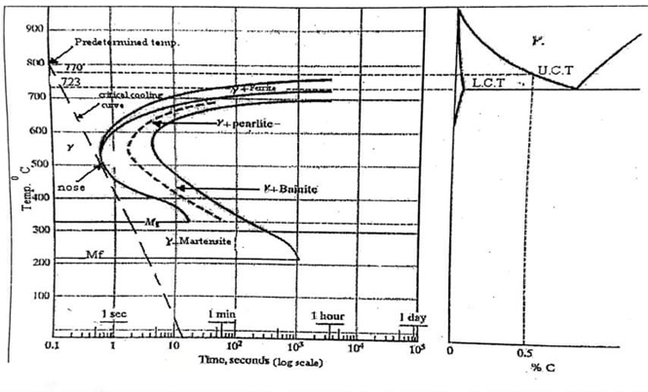

Fig.1:T.T.T Curve

**Practical Part**

**Preparing Samples**

Medium carbon steel was selected for this research, microscopic examination was performed to found the carbon ratio, the carbon ratio was about (0.4-0.43), a mineral spectroscopy device was used to determine the proportions of carbon and other chemical elements , (Table 1) the chemical composition for the carbon steel.

Table (1) : the chemical composition for the carbon steel.

|  |
| --- |
| C Ni Cr P S Mn SI Al Mo |
| 0.41 0.23 0.242 0.037 0.014 0.91 2.02 0.018 0.017 0.018 0.017 |



Fig.2: carbon steel with

(o.41) C%

(

The choice was made on medium carbon steel for the purpose of conducting tests on it, due to its many applications, as it is used in the manufacture of water pipes, gas pipes and other engineering applications. Fig.(3) shows the location of medium carbon steel on the carbon steel diagram [9].

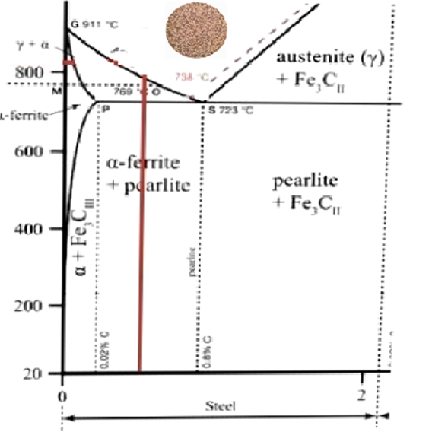



Fig.3: location of medium carbon steel on the

carbon steel diagram

**Preparing Samples:**

Twenty-seven pieces were prepared, mechanical operations were performed on them, namely cutting, grinding and smoothing , The models were cut cylindrical shape with 3cm diameter and 1cm thickness, The sample was punctured from one end for the purpose of suspending it in the corrosive medium as shown in the figure below.

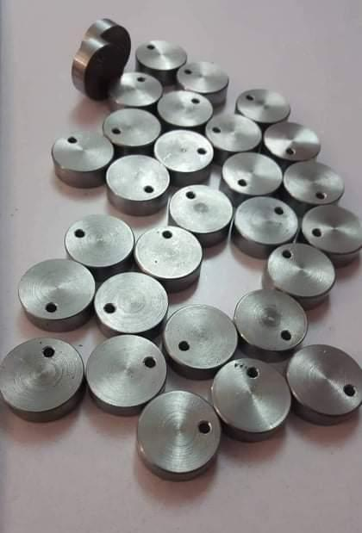

Fig.4 :Samples

**Heat treatments of carbon steel**

Thermal treatments included three treatments (annealing, normalizing and hardening), the samples were placed in an electric heating oven in the metallurgical laboratory, each nine samples were connected with a wire that has the ability to withstand high temperatures and a length of 40 cm. the samples were placed in the oven at a temperature of 850 degrees Celsius and left for a period of (15min), Samples were cooled in the following ways:

. Hardening: This process consists in rapidly cooling the samples, as they were taken out of the oven and placed in water with stirring until they cool completely, as shown in figure (5).

Normalizing: this process consists of taking the samples out of the oven and placing them in the still air until they cool down, as shown in the figure (6).

Annealing: It involves slow cooling of the samples, so the samples remain in the heating oven after turning it off until it cools down for a period of twenty-four hours.as the figure below shown, figure (7)

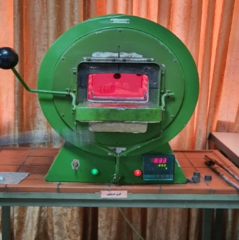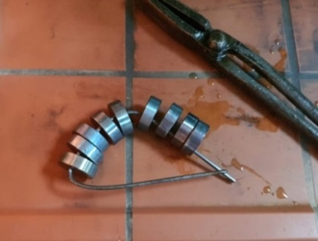

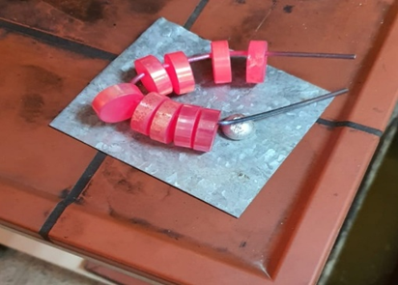

Fig.5:hardening cooling process.

Fig. 6:normalizing cooling process.

Fig.7:annealing cooling process.

from each type of carbon steel which was heat treated, we took one sample after prepared it for microscopy, the figures below shows the types of carbon steel which was



Fig.8: Micrograph for carbon steel which was heat treatment with hardening X: 160



Fig.9: Micrograph for carbon steel which was heat treatment with normalizing X: 160



Fig.10: Micrograph for carbon steel which was heat treatment with annealing X: 160

All samples were weighed using a sensitive digital balance and the weight of each sample, which represents the initial weight of the samples, was recorded.

**Corrosion medium**

All samples were placed in a corrosive medium, which is saline (95% distilled water with 5% sodium chloride) inside a glass basin of dimensions 60 X 40 X 45 cm. The salt water was analyzed to find out the proportion of chemical elements in it (Table 2) .

(Table 2): salt water was analyzed.

|  |
| --- |
| **salt water ingredients concentration** |
| CL- mg/l 245.05  Ca mg/l 16.032  Mg mg/l 13.44  Hardness mg/l 100 |

**Immersion process**

After conducting the initial weight on the samples and recording it, the samples were suspended by threads made of insulating material (nylon) in three groups, each group contains nine samples, where each group represents a type of thermally treated steel. The samples were placed inside the basin after filling it with salt water in it. After 30 days, three samples were taken from each group, washed and then each sample was weighed, the weight was recorded, (final weight) the corrosion rate was calculated. After 40 days, three more samples were taken for each type of heat treatment, and the corrosion rate was also calculated using the same method. Also, after 60 days, the last samples for each type of heat treatment were taken out of the basin and the corrosion rate was calculated.

**Calculation of corrosion rate**:

The following equation shows how to calculate the corrosion rate:

**CR.= $\frac{K×∆W}{D× A×T}$** [1]

C.R: corrosion rate (mm/year).

K: constant (87.6).

$∆W$: loss weight (mg).=initial weight – final weight

D: metal density g/cm3.

A: The surface area subjected to erosion cm2.

T : time of exposure to corrosion in hours

**Results and Discussion**

(Table 3) shows the corrosion rate values for the three heat treatments.

|  |
| --- |
| **Time(day) hardening normalizing annealing** |
| 30 0.061 0.0652 0.056  45 0.063 0.065 0.062  60 0.0962 0.0823 0.08 |

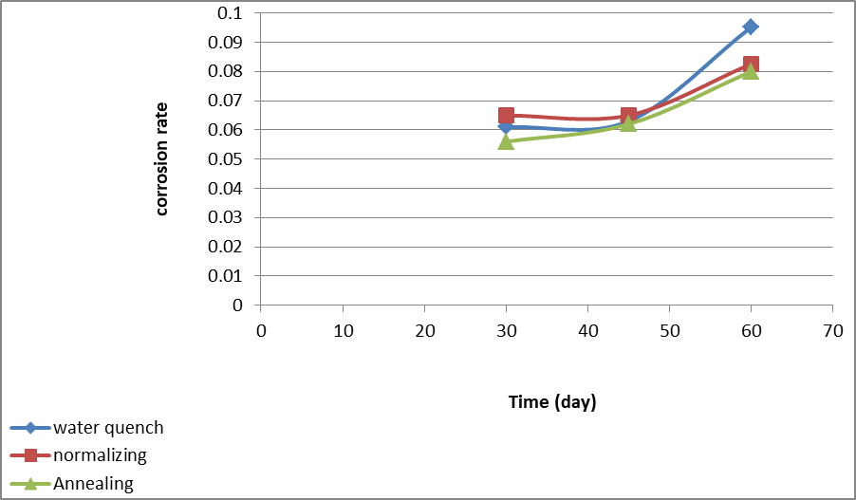

Fig. 12 :Diagram representing the relationship between

immersion time and corrosion rate.

From figure (12), There is a difference in the corrosion rates for different heat treatments. At time (30) days, the lowest corrosion rate was obtained for carbon steel heat treated by annealing , followed by carbon steel heat treated by hardening and finally steel treated by normalizing, after forty five days, the corrosion rates of the heat-treated steel by annealing increased very slightly, while the corrosion rates remained constant for both the heat-treated steel by the hardening and normalizing, at 60 days, the corrosion rates differed for all types of carbon steel, as the results showed that the hardening-treated steel obtained the highest corrosion rate, then followed by the carbon steel treated by the normalizing, lowest corrosion rate for carbon steel that treated by annealing.

The main reason for corrosion is the microstructure of the medium carbon steel, which consists of ferrite, which represents the cathodes regions, and the boundaries of cells representing the anodic regions, and in the presence of the medium of corrosion, the galvanic cell is formed thus corrosion occurs, this type is called microscopic cell corrosion, perlite forms a galvanic corrosion cell between the microscopic phases due to the difference in potential difference between ferrite and cementite. The reason for the slight stability in the corrosion rates of carbon steel at the time of 45 days compared to the time of 60 days is the formation of an oxidized layer on the surface of the steel that may reduce the corrosion process. The temperature of the hardening treatment is not different from the temperature of the treatment by the normalizing or annealing, but the main difference between these thermal treatments is the method and rate of cooling, Therefore, the reason for the high corrosion rate of hardening steel is due to the many internal stresses it was exposed to as a result of its rapid cooling in water, and this makes the metal more susceptible to corrosion m this a type is called stress corrosion. As for carbon steel treated with the formula, the increase in the corrosion rate is due to its effect on the microstructure and the number of cells, as the microscopic cells are small in size and numerous in number when compared to fermentation treatment. Whenever the number of microscopic cells is many and they are small in size, the rate of erosion will be large, because the increase in the number of cells with their small sizes leads to an increase in the areas of potential difference between the cells and boundary, and thus increase the corrosion rate, The annealing-treated steel is slowly cooled down by keeping the models in the oven, and this allows giving more time for cell growth than cooling by other methods, Corrosion medium is one of the important factors that affect the speed of corrosion rates, especially salt water, because the chloride ions present in salt increase the electrical conductivity, which leads to acceleration the corrosion process.

**Conclusion**

Heat treatments have an effect on corrosion rates through their effect on the microstructure and the number of galvanic corrosion cells between microscopic phases or between microscopic cells and their boundaries.

Whenever the number of microscopic cells is many and small in size, the corrosion rate is high, because the increase in the number of cells leads to increase in the areas of potential difference between the cells and their borders, and thus an increase in the corrosion rates .

The highest corrosion rates were in hardening steel due to the stresses it was exposed to during water quenching and the lowest corrosion rates were in annealing treated steel due to the microstructure of heat treated steel.

Corrosion medium is one of the important factors that affect the speed of corrosion rates, especially salt water, because the chloride ions present in salt increase the electrical conductivity, which leads to an acceleration of the corrosion process.

**References:**

1. Ikhlas B.A &Ghaidaa Alsarraj” Influence of Heat Treatments on the Corrosion Resistance of Medium Carbon Steel using Sulfuric Spring Water”.Tikrit Journal of Engineering Science, Issue 19,Vol. 3,2012.
2. K.R. Trethewey & J. Chaberlain, “Corrosion for Science and Engineering” 2nd ed., printed in Singapore, 1996
3. ASM Handbook “Corrosion Fundamentals, Testing, and Protection” ASM International, Volume13A 2003.
4. . Shreir, R. A. Jarman and G.T. Burstein “Corrosion Control”, Third Edition, Vol.2, 2000.
5. William D.and Callister, JR. “Materials Science and Engineering an Introduction” Seventh edition, USA2007.
6. Stephen C. D. "Galvanic Corrosion" University of Delaware, U. S. A 2003.
7. Corvo F. and Minotas J., "Changes in Atmospheric Corrosion Rate Caused by Chloric Ions Depending on Rain Regime", Journal of Corrosion Science, Vol.47, pp. 883 – 892, 2005.
8. Raja V. S., Baligidad R. G.,and Shankar Rao V., "Effect of Carbon on Corrosion Behavior of Fe3 Al Inter-metallic's in 0.5 N Sulfuric acid ", Journal of Corrosion Science, Vol. 33, pp.521–533, 2002.
9. Mohammad Y.A., "Study the Influence of Carbon Contents on the Corrosion Resistance of Plain-Carbon Steels Using Selected Corrosion Environments", M.Sc. Thesis of Production and Metallurgy, University of Mosul, Iraq, 2009.