Hybrid Model of Solar and Wind Energy for Powering Street Lights: Feasibility Study

Razan Al Kalbani
National University of Science and Technology, Oman, Razan.alk98@gmail.com

Basheer Ahamed Gani
National University of Science and Technology, Oman, basheer118@yahoo.com,

Abstract: Sultanate of Oman is targeting to implement renewable energy sources thirty percent of total energy sources within 2030. In line with the strategic plan, the hybrid model of solar and wind energy based highway lights is proposed on the Muscat highway. An attempt will be made to utilize the wind energy being generated through the movement of vehicles on the highway to change it to electrical energy to power the highway lights. Since the amount of electricity generated depends on the vehicle speed, wind direction, velocity and the placement of vertical axis wind turbines on the highway. In order to overcome the fluctuation of electricity generation, a hybrid model of solar and wind energy is proposed.to generate the maximum required electricity and provide continuous supply. As a first step in this research, the techno economic analysis has been carried out to evaluate the performance parameters such as energy production, capital expenditure, payback period and return of investment. As per the analytical model the payback period is approximately 3.2 years and the return of the investment of 221% are expected over the 10 year period The proposed next step in the research is to install hybrid model of PV solar cells and VAWTs on the median of the Muscat highways between As Seeb and Al Ruwi to see the potential to augment the electricity generation from the vehicle induced turbulence on the natural wind.
Keywords: Renewable energy, VAWT, Solar, Highway, Payback period

Introduction

Climate change and depletion of fossil fuel reserves are the two biggest challenges the world faces. Greenhouse gases consist of Carbon dioxide, Nitrous oxide, and Methane, and they are produced during the combustion of fossil fuels. In order to secure future energy, it is widely accepted by most countries to utilize Renewable Energy sources in the energy sector..

The Sultanate of Oman's energy requirement and economy is still highly dependent on the fossil fuel sector (("Oman energy situation," n.d.)), which is eventually responsible for their higher per capita CO₂ emissions CO₂ emissions (metric tons per capita) in Oman were reported at 101.7895 (MtCO₂) in 2014, and it is contributing 0.22% of the global greenhouse gas emissions for just 0.06% of the world's population ((Abdul-Wahab et al., 2015).. Hence, to reduce the carbon dioxide emissions and the gap between energy supply and demand, additional cheaper, environment-friendly energy sources are required other than 'the regularly used fossil fuels and gases. There are several studies carried out to reduce the carbon emission related issue. (Jenkins et al.,(2019) have done the case study in Libya to see the potential of using solar and wind energy system. Mohammadi et al.. (2014) have conducted the study in Iran for the use of large scale wind turbine as a alternate source of energy to meet the electricity demand. Both the studies suggested that there is a potential to augment the electricity generation with the reduction in toxic gases..

Due to the availability of perfect high-quality roads, cheaper fuel, and the economic status of the individuals in Oman, there was a steep increase in the number of personal vehicles.Also, due to the increase in the population every year, there was a steep increase in the demands of basic amenities, raw materials, and resources. These all are transported through heavy vehicles. Hence, the growth rate of the movement of all types of vehicles on high-quality roadways is increased. The idea of harvesting energy from the movement of vehicles has been proposed in several studies. Teskiin et al (2009) designed a combined solar and wind system to generate electric power from the moving cars using Savonius wind turbine No theoretical and experimental analysis done. Tian et al., (2017), has studied the velocity of cars and the gaps between the cars and rotor. The work did not consider the vehicle types and the movement of the vehicles in more than one lane.
In this proposed work, there are two objectives: The first objective is to evaluate the suitability of installing the hybrid solar and wind turbine on the median of highway without hindering the vehicle movements, safety and considering economic benefits using the cost flow model. The second objective is to investigate the vehicle kinetic motion turbulence on the road to augment the production of electricity using SB-VAWT wind turbine through experimental analysis using vehicle speed, vehicle to vehicle gap, vehicle types and vehicle movements on the opposite sides. In this paper, the work is mainly focused on the design of solar and wind turbine considering Oman weather data and pay back and return of investment from the hybrid solar and wind energy.

General concept of proposed Solar and Wind Hybrid model

Solar and wind resources are often complementary, hybrid system provide a more consistent year round output than either wind only or PV only system (Chiras, 2010). Moreover, hybrid system often require smaller electric arrays and smaller wind generators then if either was the sole source of electricity. According to Oman weather data (("Data Portal," n.d) from 2012 to 2016 shown in Figure 1 the average wind speed is around 6.91 m/s and the average temperature is 27.29°C which is suitable for hybrid solar and wind energy generation.

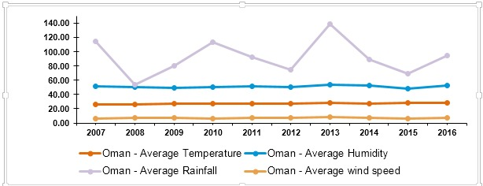

Figure 1. Oman weather data (("Data Portal," n.d)
Proposed System Model

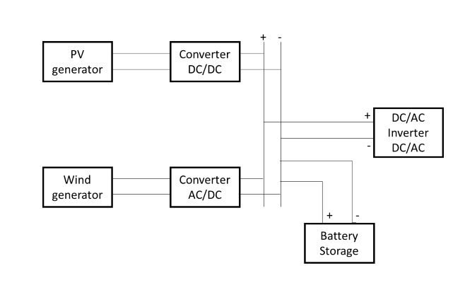
Figure 2. Block diagram of Hybrid Solar and Wind system with battery storage
The proposed system model shown in Figure2 comprises of a small Vertical Axis Wind Turbine (VAWT) with straight blade type to be placed on the median of the Muscat highway to change the kinetic wind energy into mechanical power and then into electrical power using generator. Since the electricity generation depends on the wind speed and the wind speed is affected by pressure variation due to temperature variation and also on the traffic intensity of vehicles movement. In order to address this issue and to generate constant output the Photovoltaic (PV) cells are used along with wind turbine. In Oman the sun is shining 340 days out of 365 days therefore, the maximum electricity may be generated. Solar energy is present only during the day and the highway lights are switched ON only during night. AC to DC converter is required to store the energy from the wind turbine in the battery. Charge controller is required to provide maximum output and switch off the battery when the battery reaches the full capacity. Highway lights are powered from the battery using invertors.

Wind Energy System
Straight blade VAWT has simple construction because it uses straight blades attached to a shaft using struts and has a better aerodynamics performance. It can harvest winds from any given directions (Bhatia & Gupta, 2018). There are several key elements in the wind power equation.
Power (P) = ½ ρAv³ (1)
The most important parameter is the wind velocity. Since it is cubed the small variation in the wind velocity will result higher increase in the power output. The next element of the importance is the rotor swept area which is product of blade length and rotor diameter. Next importance is the density of air. The density of air is directly related to the elevation above sea level, temperature and pressure. Increasing temperature causes the air density to decrease and the increase in pressure increases the air density/ According to (Abraham et al., 2012)) the air density can be estimated using the following equation if the air temperature and pressure are unknown.
Ρ = 1225 – (0.00011 *2) (2)
All of the energy available in the wind cannot be converted into useful power. According to Betz limit 16/27 or 59% of the power can be extracted from the wind using the concept of momentum theory. The fraction of power extracted from the wind by a rotor is called the coefficient of performance or efficiency of the rotor (C_{P}). Wind turbine with frictional losses, aerodynamic drag and. the induction factor can be related to the ratio of rotation of tip speed of the rotor to the wind speed is called Tip Speed Ratio (TSR). The maximum rotor efficiency is 48-50% at TSR 8.To complete the conversion of power in the wind to electrical power gear and generators are used. The low speed shaft is couple to gear to increase the shaft speed and the higher shaft speed is coupled to the generator to produce electricity.

Design Calculations
In Muscat highway, every 100m a lamp post with 70 W lights are used. Using the Electrical power equation as given below
Electrical Power = Wind power * (C_{P}) * Efficiency of mechanical (η) (3)
$\text{Wind} \text{power} =\frac{\text{70}}{0\text{.}5 ∗ 0\text{.}6}$= 200 W
Considering the average wind velocity 6.91m/s in Oman, the rotor swept area can be calculated.
$\text{Rotor} \text{swept} \text{area} =\frac{\text{200} ∗ 2}{\text{/ 1,225 * 6}\text{.}\text{91} \text{*6}\text{.}\text{91} \text{*6}\text{.}\text{91 }}$ = 1 m² (4)
Swept area (A = D *H) is the product of Rotor diameter and height of the blade. The value of D and H is 1 m each. According to Maxwell &McGowan (2009) the wing width is 0.14 times the diameter which is 140mm and the wing chord is 0.09times the rotor circumference which is 565mm.

Solar Energy System
In order to design a PV system, the total load or daily energy consumption has to be determined. On the basis of desired load, the number of PV modules and the battery voltage required to meet daily energy demand can be calculated.

Table 1. Load profiling of Highway lights
Load | Power | Average daily hours of use | Energy consumption per day
Lights | 70 W | 12 | 840 W
PV energy is usually designed considering the lower solar insolation value that generally occurs during the winter month. Batteries are deep cycle batteries and should provide storage during no sunshine or rainy periods. Batteries must not be allowed to discharge below 50-60%. Charge controller is required to prevent over charging and deep discharging of the battery. It also acts as a charge regulator and protects the battery.

Design Calculations

$\text{Array} \text{load}=\frac{\text{Total daily load }(\text{Wh/day})}{\text{Battery efficiency*charge controller efficiency}}$ (5) $=\frac{\text{840}}{(0\text{.}8∗0\text{.}9)}=\text{1187 Wh/day}$
$\text{Array} \text{size}=\frac{\text{Array} \text{load}}{(\text{Insolation * Mismatch factor})}$ (6)
$=\frac{\text{1187}}{7 ∗ 0\text{.}\text{85}}$ = 200 Wp
The option available are 4 modules of 50Wp or 1 module of 220 Wp.
$\text{Battery} \text{capacity} =\frac{\text{Daily} \text{Load} ∗ \text{Reserve} \text{backup}}{\text{Nominal voltage * maximum allowable discharge}}$ (7)
$=\frac{\text{1000} \text{Wh/day} ∗ 1}{\text{24} ∗ 0\text{.}6}$ = 70 Ah
Cost Flow Analysis
The life span of wind turbine and PV cells are generally from 25 to 30 years whereas the electronics and battery used will last from 6 to7 years. The hybrid solar and wind energy system requires initial high investments during installation prior to generation of electricity is given in Table 2.
Table 2. Hybrid Solar and Wind Energy System cost
Name of the Hybrid Energy system components | Specifications | Quantity | Approx. Cost
Anemometer |  | 1 | USD 65
Wind Turbine generator kit with charge controller | Giromil Spiral vertical 12 V/400 W | 1 | USD 520
Solar flexible panel with charge controller | 12 V30 A//400 W | 3 | USD 380
Sahar cool multifunction light | 40 W | 2 | USD 37
GEL battery 12V/100AH | 12 V/100 AH | 1 | USD 273
PVC copper wires | 2.5 square mm | 60 m | USD 60
Inverter | 240/2000 W | 1 | USD 65
Total System cost USD 1400

The Capital expenditure includes total system cost plus 5% transportation and 10% installation from the total system cost which is USD 1610. 10% maintenance cost will be added only from the second year of operation till the life span of the system.

Table 3. Hybrid solar and wind energy system performance
Performance measure | Quantity | Unit
Average energy produced per hour | 0.4 | kW/h
Average energy produced per day  (Wind energy for 20 hours/day and solar energy 10 hours per day) | 6 | kW/day
Average energy produced annually | 2190 | kW
Average cost of power without subsidy | 0.3 | USD
Average daily saving | 1.8 | USD
Average annual saving | 657 | USD

According to Abraham & Plourde (2014) the Payback period and Return of Investment is calculated.
$\text{Paybackperiod}=\frac{\text{Capital} \text{expenditure}}{\text{Annual} \text{energy} \text{savings} − \text{maintenance} \text{cost}}$ (8)
$=\frac{\text{1610}}{\text{657}−\text{140}}$ = 3.2 years

Return on Investment (ROI) is calculated for 6 years considering the electronics and battery replacement.
$\text{ROI}=\frac{(\text{517} ∗ 6)−\text{1610}}{\text{1610}}$= 92.6 % (9)

Results and Discussion

Wind and solar energy load profiling has been done through design calculation and the type, size of VAWT , Number of PV modules battery specifications and the power output are evaluated. Cost flow models consider the parameters such as the capital expenditure, maintenance and operation charges, annual cost of saving through renewable energy to assess the payback period, return of investment and the amount of Co₂ reduction. Figure 3 shows the high initial investment is required during the first year before generating electricity. The maintenance charges accounts only 8-9% of the initial investment in the subsequent years.

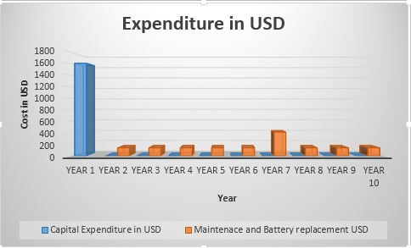

Figure 3. Capital expenditure and maintenance cost

The cost flow model suggests that the payback period is 3.2 years without subsidy for the energy generation using fossil fuel which a good indicator to reduce energy expenditure. Return of investment is apparent from year 4 and increasing steadily to 221% during year 10 as evident from the histogram shown in figure 4. This clearly shows that annual energy cost saving after payback period and indirectly cutting the state expenditure on the highway lights.

. 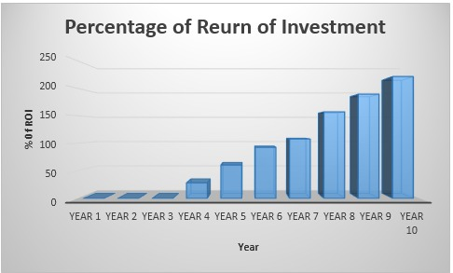
Figure 4. Return of Investment
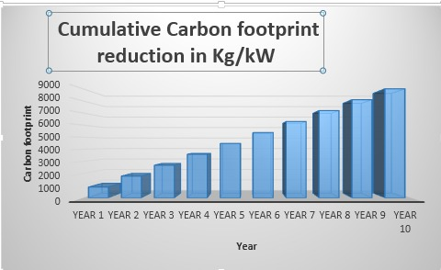

Figure 5. Reduction of CO₂ from the renewable energy

Studies shows that a negative emission of up to -410g CO₂ per Kw can be achieved (Bhatia & Gupta.2018). Figure 5 shows the significant amount of CO2 reduction over the years for a single hybrid solar and wind energy model.

The Muscat highway from As Seeb to Al Ruwi has a stretch of 50 km has the highway light installed approximately every 100 m requires 500 hybrid solar and wind system which incurs the capital expenditure of USD 805000 and expected to produce 10,95000 kW annually. If the proposed hybrid solar and wind energy model are installed, the government could save USD 82,563 annually as per the subsidized tariff. The amount of reduction in CO₂ is approximately 448.95Mt which will be positive step for the attainment of the green energy vision.

Conclusion

From technical analysis it is evident that hybrid model is the best option for using it on the highway for lighting the highway lights in terms of space requirements, environmental factors and cost compared to if either the solar only energy or wind only energy was used. As per the design the rotor size is 1m² which can easily installed on the median of the highway without hindering the traffic movement and straight blade VAWT will not affect natural habitats such as birds and can be installed near to the ground. The cost flow model suggests that the payback period is 3.2 years without subsidy for the energy generation using fossil fuel which is a good indicator to reduce energy expenditure. Return of investment is calculated for first 10 years period and found to be 221%. The negative carbon emission over the 10 years period is expected to be 8977 kg/kW for a single hybrid solar and wind energy model. If the proposed hybrid solar and wind energy model is installed over the stretch of 50 km of Muscat highway would considerably reduce the state expenditure for the energy consumption and reduce carbon emission to the significant level. The proposed next step in the research is to install the proposed hybrid model of PV solar cells and VAWTs on the median of the Muscat highways to investigate the effect of vehicle turbulence on the wind turbine to augment the electricity generation.

Recommendations

If the proposed hybrid solar and wind energy model is installed over the stretch of 50 km of Muscat highway as a pilot study that would considerably reduce the state expenditure for the energy consumption and reduce carbon emission to the significant level.

References

Abdul-Wahab, S. A., Charabi, Y., Al-Maamari, R., Al-Rawas, G. A., Gastli, A., & Chan, K. (2015). CO2 greenhouse emissions in Oman over the last forty-two years: Review. Renewable and Sustainable Energy Reviews, 52, 1702-1712. https://doi.org/10.1016/j.rser.2015.07.193
Abraham, J., Plourde, B., Mowry, G., Minkowycz, W. and Sparrow, E., 2012. Summary of Savonius wind turbine development and future applications for small-scale power generation. Journal of Renewable and Sustainable Energy, 4(4), p.042703
Abraham, J.P, & Plouride, B. (2014), Small scale wind power design, analysis and environmental impacts. Momentum Press.
Bhatia, S. C., & Gupta, R. K. (2018). Textbook of renewable energy. Woodhead Publishing India PVT. LTD.
Chiras, D. (2010). Wind power basics : A green energy guide. New Society Publishers.
Jenkins, P., Elmnifi, M., Younis, A., & Emhamed, A. (2019). Hybrid Power Generation by Using Solar and Wind Energy: Case Study. World Journal of Mechanics, 09(04), 81–93. https://doi.org/10.4236/wjm.2019.94006.
Manwell, J.F., McGowan,J.G., & Rogers, A.L (2009) Wind Energy Explained: Theory, Design and Applications. John Wiley & Sons Ltd
Mohammadi, K., Mostafaeipour, A., Dinpashoh, Y., & Pouya, N. (2014). Electricity Generation and Energy Cost Estimation of Large-Scale Wind Turbines in Jarandagh, Iran. Journal of Energy, 2014, 1–8. https://doi.org/10.1155/2014/613681
Data Portal. (n.d.). Knoema. https://data.gov.om/L
Oman energy situation. (n.d.). energypedia.info. https://energypedia.info/wiki/Oman_Energy_Situation
Taskin, S., Dursum, B., & AlBoyaci, B. (2009). Performance Assessment of a Combined Solar and wind System. The Arabian Journal of Science and Engineering, 24
Tian, W., Mao, Z., & Li, Y. (2017). Numerical Simulations of a VAWT in the Wake of a Moving Car. Energies, 10(4), 478. https://doi.org/10.3390/en10040478.

